Incidents
AWARDS Implementation Requests Form

Overview
As part of the AWARDS implementation process, agencies/continuums can make adjustments to the information collected during the entry and review of incident reports within the Incidents module. This document is intended to guide you through each of the available Incidents options, and to provide you a form with which to request them.

Request Form Instructions
To request that the incidents functionality be customized in your AWARDS database, do the following:
- Discuss the available options with your AWARDS implementation team and/or any other relevant staff.
- Complete this request form, including the Requestor Information and the Request Details for each option.
- Save the completed form to your PC.
- Email the completed form to your Implementation Consultant or to requests@footholdtechnology.com.
Once your request form has been received, we will review it carefully and the requested options will be deployed to your AWARDS database. We may contact you prior to deployment if, after reviewing your requests, we have any questions or concerns about your selections.

Available Incidents Options
To jump ahead to the information regarding a specific option, click it in the list below.
Incidents Form
Option 1 – Available / Required Fields and Options
Option 2 – Record and Field / Option Labels
Option 3 – Incident Types List
Option 4 – Witness Categories List
Incidents Access
Option 5 – Initial Report Access Override Permission
Incidents Index
Option 6 – Location Search Field

Requestor Information
Customer Name: [enter customer / database name here]
Requestor Name: [enter your name here]

Option 1 – Incidents Form > Available / Required Fields and Options
AWARDS Location: Incidents > Initial Incident Report
Enhancement Description: This enhancement enables agencies to determine which fields and options are available on initial incident reports in AWARDS. In addition, it allows a subset of those fields and options to be set as required.

Request Details
In this table click the Display checkbox for each field/option that should be included on initial incident report records in your AWARDS database. For each field/option you are choosing to display (or that is displayed by default), also click the corresponding Required checkbox (when available) if users should be prevented from saving the record until a value has been entered using that field/option. Each required field/option is displayed on the incident data entry page with a red asterisk (*).
- Tip: When making your selections, keep in mind that the labels on some fields/options are configurable, as noted with a green asterisk ( *). To specify labels other than the defaults, see Option 2 – Record and Field / Option Labels.
Field / Option | Display | Make Required | Program Types
911 Responders – Form section including multiple rows, each with a text fields for name, badge ID, time called, time arrived, service requested, and first aid provided, along with a category selection of “Fire,” “Police,” and “EMS.” |  | N/A | [enter program types list here]
Apparent Causes, If Known * – Text box. |  | N/A | [enter program types list here]
Block – Text field. |  | N/A | [enter program types list here]
Boro – Text field. |  | N/A | [enter program types list here]
Building ID – Text field. |  | N/A | [enter program types list here]
City – Text field. |  | N/A | [enter program types list here]
House Number – Text field. |  | N/A | [enter program types list here]
Immediate Measures Taken Within 24 Hours * – Text box. |  | N/A | [enter program types list here]
Incident Notifications – Form section including text fields for persons notified, agency, date, and time. |  | (time only) | [enter program types list here]
Incident Time – HH:MM AM/PM field. |  |  | [enter program types list here]
Incidents File Cabinet – Allows files to be uploaded to incidents. |  | N/A | [enter program types list here]
Incident Report Filed By – Text field. |  | N/A | All program types
Internal ID * – Text field, the location of which can be specified – top of form, or bottom. | Top Bottom |  | [enter program types list here]
Lot – Text field. |  | N/A | [enter program types list here]
Field / Option | Display | Make Required | Program Types
Participants – Form section including multiple rows, each with a selection list for clients (containing list of current clients in selected program), selection list for employees, and text field for others. |  |  | [enter program types list here]
Results of Immediate Measures * – Text box. |  | N/A | [enter program types list here]
Severity – Drop-down selection list with choices for “Critical,” “Sentinel,” and “Other.” This list cannot be modified. |  |  | [enter program types list here]
State – Text field. |  | N/A | [enter program types list here]
This report was filed outside of [agency name] – Check box. |  | N/A | All program types
Witnesses – Form section including multiple rows, each with a name text field, badge/ID/company text field, and category selection list. (See also: Option 4 – Witness Categories List ) |  | N/A | [enter program types list here]
Zip - Text field. |  | N/A | [enter program types list here]
(new-incident.w: cfg-extra-fields) | (new-incident.w: cfg-extra-required) | (new-incident.w: cfg-internalid-placement)
(incident.w: cfg-omit-external-notify-checkbox) | (incident.w cfg-extreporter)

Option 2 – Incidents Form > Record and Field / Option Labels
AWARDS Location: Incidents > Initial Incident Report
Enhancement Description: This enhancement enables agencies to change the label of incident records themselves (using an alternative to the word “incident”) as well as to change the labels on the following fields and options within incident records: Internal ID, Location, Apparent Causes, If Known, Immediate Measures Taken Within 24 Hours, Results of Immediate Measures

Request Details
All components of this enhancement can be set individually at the program type level. Keep in mind that you may have chosen not to display some of these items under Option 1 – Available / Required Fields and Options.
- Incident - Record Label (replaces “Incident” in all labeling, including reports and data entry fields/options)
Setting | Label | Program Types
Use the default label | Incident | [enter program types list here]
Use a custom label | [enter custom label here] | [enter program types list here]
 | [enter custom label here] | [enter program types list here]
 | [enter custom label here] | [enter program types list here]
 | [enter custom label here] | [enter program types list here]
(new-incident.w: cfg-incident-relabel)

- Internal ID - Field Label (Only applicable when set to display using Option 1.)
Setting | Label | Program Types
Use the default label | Internal ID | [enter program types list here]
Use a custom label | [enter custom label here] | [enter program types list here]
 | [enter custom label here] | [enter program types list here]
 | [enter custom label here] | [enter program types list here]
 | [enter custom label here] | [enter program types list here]
(new-incident.w: cfg-internalid-label)
- Location – Field Label
Setting | Label | Program Types
Use the default label | Location | [enter program types list here]
Use a custom label | [enter custom label here] | [enter program types list here]
 | [enter custom label here] | [enter program types list here]
 | [enter custom label here] | [enter program types list here]
 | [enter custom label here] | [enter program types list here]
(new-incident.w: cfg-location-label)
- Apparent Causes, If Known – Text Box Label (Only applicable when set to display using Option 1.)
Setting | Label | Program Types
Use the default label | Apparent Causes, If Known | [enter program types list here]
Use a custom label | [enter custom label here] | [enter program types list here]
 | [enter custom label here] | [enter program types list here]
 | [enter custom label here] | [enter program types list here]
 | [enter custom label here] | [enter program types list here]
(new-incident.w: cfg-apparent-causes-label)
- Immediate Measures Taken Within 24 Hours – Text Box Label (Only applicable when set to display using Option 1.)
Setting | Label | Program Types
Use the default label | Immediate Measures Taken Within 24 Hours | [enter program types list here]
Use a custom label | [enter custom label here] | [enter program types list here]
 | [enter custom label here] | [enter program types list here]
 | [enter custom label here] | [enter program types list here]
 | [enter custom label here] | [enter program types list here]
(new-incident.w: cfg-immediate-measures-label)
- Result of Immediate Measures – Text Box Label (Only applicable when set to display using Option 1.)
Setting | Label | Program Types
Use the default label | Result of Immediate Measures | [enter program types list here]
Use a custom label | [enter custom label here] | [enter program types list here]
 | [enter custom label here] | [enter program types list here]
 | [enter custom label here] | [enter program types list here]
 | [enter custom label here] | [enter program types list here]
(new-incident.w: cfg-immediate-results-label)

Option 3 – Incidents Form > Incident Types List
AWARDS Location: Incidents > Initial Incident Report
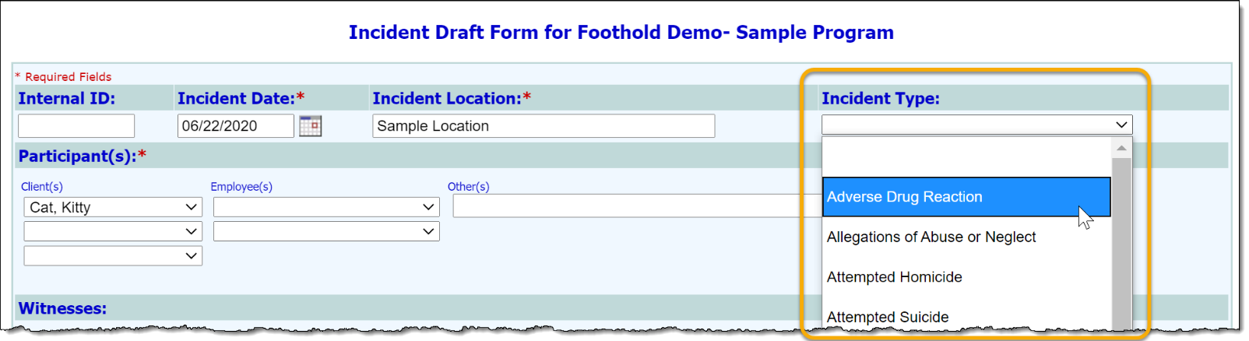
Enhancement Description: For each initial incident report created, a type can be specified using an optional Incident Type option. The selections available in the types list are configurable. You can choose to implement the default list, or your own custom lists for specific programs.

Request Details
Setting | List | Programs
Use the default list | Accidental Injury  Aggravated Assault  Allegations of Abuse or Neglect  Assault  Child Abuse  Endangering the Safety of Another Person  Fight  Fire  Homicide Attempt  Medication Error  Missing Client  Neglect  Physical Abuse  Sexual Abuse  Psychological Abuse  Self-Abuse  Severe Adverse Drug Reaction  Sexual Assault  Suicide  Suicidal Attempt  Crime  Unexpected Death  Unexplained Injury  Undetermined | [enter programs list here]
Use a custom list | [enter list contents here] | [enter programs list here]
 | [enter list contents here] | [enter programs list here]
 | [enter list contents here] | [enter programs list here]
 | [enter list contents here] | [enter programs list here]
 | [enter list contents here] | [enter programs list here]
(incident.w: cfg-inccodes) | (incident.w: cfg-incitypes) | (incident.w: cfg-master-inctype)

Option 4 – Incidents Form > Witness Categories List
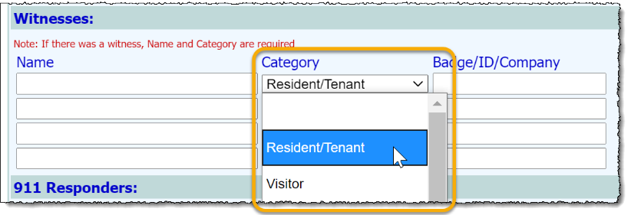
AWARDS Location: Incidents > Initial Incident Report
Enhancement Description: For each witness entered in the corresponding portion of the initial incident report form a Category can be selected for the purposes of identifying not only the witnesses’ name, but his or her type as well (as shown here). The selections available in the categories list is configurable. You can choose to implement the default list, or your own custom list.

Request Details
Default List | Custom List
Use the default witness types list:  Client  Visitor  Service Coordinator  Housing Coordinator  Medication Coordinator  Program Director  Peer Specialist  Operations  MHT  Counselor  Receptionist  Other Staff | Use this custom list:  [enter list here]
(incident.w: cfg-witness-base-list) | (incident.w: cfg-extended-witnesses)

Option 5 – Incidents Access > Initial Report Access Override Permission
AWARDS Location: Incidents > Initial Incident Report
Enhancement Description: By default, only an incident report’s original author and program directors/deputy directors can edit that report. This enhancement enables agencies to expand the editing ability to other staff based on the job titles assigned to them in AWARDS.
- Tip: Job titles are assigned under Human Resources > Staff Information > Work Role tab > Job Titles option.
Specifically, any user with a job title on the agency-approved override list will be able to edit any initial incident report, regardless of the standard incident rules. These users will also be able to view all initial incident report details and comments added by others within incident reports and the Incidents ReportBuilder.
Note that the override capability is limited as follows:
- Users must still have chart access permission to the program for which the incident was reported.
- Users to whom this override applies cannot add comments to an initial report, but can update the report itself.
- Incident reviews continue to be subject to regular incident permissions/rules, regardless of this override.
  - Note: For more information on incidents workflow, including access rules for initial incident reports and incident reviews, please refer to Online Help.

Request Details
This enhancement is set at the program type level. In each row, please specify an authorized job titles list for one or more program types. Job titles entered here must exactly match those in the AWARDS list available under Human Resources > Staff Information > Work Role tab > Job Title list.
Setting | Job Titles | Program Types
NO, we do not want expanded access.
YES, turn on expanded access for: | [enter job titles here] | [enter program types list here]
 | [enter job titles here] | [enter program types list here]
 | [enter job titles here] | [enter program types list here]
 | [enter job titles here] | [enter program types list here]
 | [enter job titles here] | [enter program types list here]
(new-incident.w: cfg-permissions-override)

Option 6 – Incidents Index > Location Search Field
AWARDS Location: Incidents > Index Page
Enhancement Description: This enhancement adds a Location search feature to the incidents index page shown when a user accesses the Incidents module in data entry mode (as shown here).
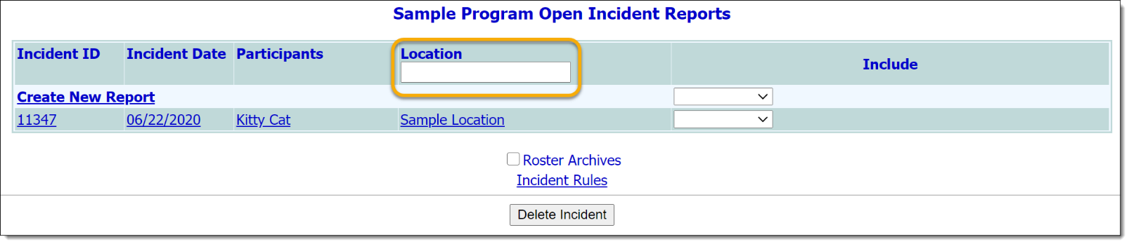
When the search feature is enabled, a user can begin to type the location of the incident they are looking for in this field, and the list of open incidents will automatically be filtered down to display only those with matching values in the “Location” column of the index table.

Request Details
Setting
NO, we do not want the Location search enabled. | YES, we want the Location search enabled.
(new-incident.w: cfg-incidents-search)

