Human Resources
AWARDS Implementation Requests Form

Overview
As part of the AWARDS implementation process, agencies/continuums can make adjustments to the information collected during the entry and maintenance of employee Staff Information records within the Human Resources module. The work flow and settings for Staff Training records can also be configured. This document is intended to guide you through each of the available Staff Information and Staff Training options, and to provide you a form with which to request them.

Request Form Instructions
To request that the human resources functionality be customized in your AWARDS database, do the following:
- Discuss the available options with your AWARDS implementation team and/or any other relevant staff.
- Complete this request form, including the Requestor Information and the Request Details for each option.
- Save the completed form to your PC.
- Email the completed form to your Implementation Consultant or to requests@footholdtechnology.com.
Once your request form has been received, we will review it carefully and the requested options will be deployed to your AWARDS database. We may contact you prior to deployment if, after reviewing your requests, we have any questions or concerns about your selections.

Available Human Resources Options
To jump ahead to the information regarding a specific option, click it in the list below.
Staff Information Records
Option 1 – Available / Required Fields and Options
Option 2 – Credentials – Authorization Credentials List
Option 3 – Demographics – Ethnicity List
Option 4 – Payroll – Benefits List
Option 5 – Payroll – Leave Types List
Option 6 – Work Role – Departments List
Option 7 – Work Role – EEO Job Classifications List
Staff Training Records *
Option 8 – Custom Training Topics List
Option 9 – Training Cost Field
Option 10 – Mandated Training Attendance Option
- Tip: * While defined as “Human Resources” functionality for the purposes of this document, the location of the Staff Training feature in AWARDS varies based on a user’s permissions; specifically, based on those permissions it is available to users who have access from one or more of the following locations: Human Resources module, Services – Group module, AWARDS Home screen, and Calendar.

Requestor Information
Customer Name: [enter customer / database name here]
Requestor Name: [enter your name here]

Option 1 – Staff Information > Available / Required Fields and Options
AWARDS Location: Human Resources > Staff Information
Enhancement Description: This enhancement enables agencies to determine which fields and options are available on the staff information records used to record employee information in AWARDS. In addition, it allows specified fields and options to be set as required.

Request Details
In this table click the Display checkbox for each field/option that should be included on staff information records in your AWARDS database. For each field/option you are choosing to display (or that is displayed by default), also click the corresponding Required checkbox if users should be prevented from saving the record until a value has been entered using that field/option. Each required field/option is displayed on the staff information page with a red asterisk (*).
- Tip: The staff information record for an employee must be completed before an AWARDS login can be created for him/her. Keep that in mind and use caution when specifying which fields/options are to be required, as it means that a login cannot be created unless/until those required pieces of data are all available and entered.
Info Type – Field / Option | Display | Make Required
Credentials – Credential Expiration (see also: Option 2 – Authorization Credentials List)
Credentials – Degree | on by default
Credentials – Degree School | on by default
Credentials – Degree Year | on by default
Credentials – Highest Grade Level | on by default
Credentials – Languages | on by default
Credentials – License Type Code | on by default
Credentials – Medicaid Provider ID | on by default
Credentials – Medicare Provider ID | on by default
Credentials – National Provider Identifier | on by default
Credentials – Professional License # | on by default
Demographics – Agency Employee ID Number
Demographics – AWARDS Employee ID (read-only)
Info Type – Field / Option | Display | Make Required
Demographics – Birth Date | on by default
Demographics – Cell Phone | on by default
Demographics – Comments
Demographics – Driver Info – Agency Driver | turned on together
Demographics – Driver Info – Driver’s License #
Demographics – Driver Info – Driver’s License Effective Date
Demographics – Driver Info – Driver’s License Expiration Date
Demographics – Driver Info – Driver’s License State
Demographics – Emergency Contact Person / Phone | on by default
Demographics – Emergency Contact Relation | on by default
Demographics – Emergency Medical Information | on by default
Demographics – Ethnicity (see also: Option 3 – Ethnicity List) | on by default
Demographics – Fax Number
Demographics – Gender | on by default
Demographics – Home City-State-Zip | on by default
Demographics – Home Phone | on by default
Demographics – Home Street Address | on by default
Demographics – IRS Exemptions | on by default
Demographics – Login Creation Date (read-only)
Demographics – Marital Status | on by default
Demographics – Middle Name | on by default
Demographics – Personal Email Address | on by default
Demographics – Social Security Number | on by default
Demographics – US Citizen / Country | on by default
Demographics – Work Email Address | on by default
Demographics – Work Phone
Medical Info – Annual TB Testing – Effective Date |  | required together
Medical Info – Annual TB Testing – Renewal Date
Medical Info – Annual TB Testing – Results
Info Type – Field / Option | Display | Make Required
Medical Info – Chest X-Ray – Date |  | required together
Medical Info – Chest X-Ray – Results
Medical Info – Hepatitis – Series 1 – Date |  | required together
Medical Info – Hepatitis – Series 1 – Tested
Medical Info – Hepatitis – Series 2 – Date |  | required together
Medical Info – Hepatitis – Series 2 – Tested
Medical Info – Hepatitis – Series 3 – Date |  | required together
Medical Info – Hepatitis – Series 3 – Tested
Miscellaneous Info – Code of Ethics Form Signed / Expiration Date
Miscellaneous Info – Training Dates
Payroll – Benefits Info – Eligible (see also: Option 4 – Benefits List) | turned on together
Payroll – Benefits Info – Eligibility Date (see also: Option 4 – Benefits List)
Payroll – Benefits Info – Enrolled (see also: Option 4 – Benefits List)
Payroll – Benefits Info – Enrolled Date (see also: Option 4 – Benefits List)
Payroll – Leave of Absence Type (see also: Option 5 – Leave Types List)
Work Role – Department (see also: Option 6 – Departments List)
Work Role – EEO Job Class (see also: Option 7 – EEO Job Classification List)
Work Role – Job Title | on by default
Work Role – Time Off Approval Supervisor | on by default
Work Role – Time Sheet Data Supervisor | on by default
(employee.w: cfg-hr-fields) | (employee.w: cfg-required-fields) | (employee.w: cfg-medical-fields)

Option 2 – Staff Information > Credentials – Authorization Credentials List
AWARDS Location: Human Resources > Staff Information > Credentials tab
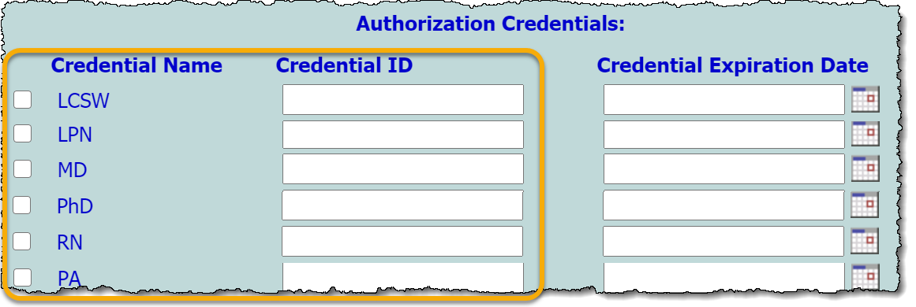
Enhancement Description: This enhancement enables agencies to determine which credentials to track for staff. For each credential type specified here, a Credential Name check box and Credential ID field are available on the Staff Information record’s Credentials tab, as shown here. (An optional Credential Expiration field can also be displayed for each, using Option 1.)
- Tip: If your agency has chosen to use the AWARDS BillingBuilder functionality, this enhancement helps determine staff credential criteria for billing purposes.

Request Details
Setting
No, we will NOT be tracking authorization credentials | Yes, we WILL be tracking authorization credentials. Use this list:  [enter list here]
(entcert.w: cfg-credentials-list)

Option 3 – Staff Information > Demographics – Ethnicity List
AWARDS Location: Human Resources > Staff Information > Demographics tab
Enhancement Description: This enhancement enables agencies to determine the selections found in the Ethnicity drop-down list on the Demographics tab of staff information records. By default the Equal Employment Opportunity (EEO) ethnicity list is used. You can choose to implement this default list, or your own custom list.

Request Details
Default List | Custom List
Use the default (EEO) ethnicity list.  White (not Hispanic or Latino)  Black or African American (not Hispanic or Latino)  Hispanic or Latino  Asian (not Hispanic or Latino)  American Indian / Alaskan Native (not Hispanic or Latino)  Native Hawaiian or Other Pacific Islander (not Hispanic or Latino)  Two or More Races (not Hispanic or Latino) | Use this custom list:  [enter list here]
(employee.w: cfg-ethniclist)

Option 4 – Staff Information > Payroll – Benefits List
AWARDS Location: Human Resources > Staff Information > Payroll tab
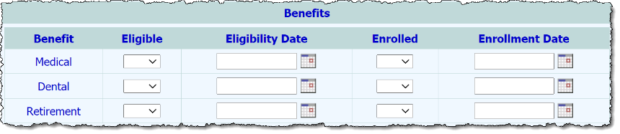
Enhancement Description: When benefits-related fields/options are included on the staff information record (see Option 1), the list of benefits for which those fields/options are available must be specified. Each benefit will display as a separate row in a “Benefits” section of the staff information record’s Payroll tab. Those rows are each populated with the benefits-related fields/options specified in Option 1.
In the example at right, the benefits list is comprised of the defaults – Medical, Dental, and Retirement – and all available benefits fields/options have been turned on in Option 1.

Request Details
Default List | Custom List
Use the default benefits list:  Medical  Dental  Retirement | Use this custom list:  [enter list here]
(employee.w: cfg-employee-benefits)

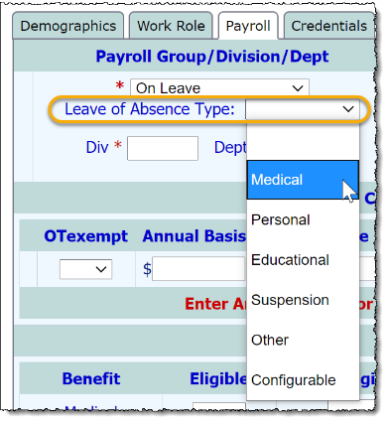
Option 5 – Staff Information > Payroll – Leave Types List
AWARDS Location: Human Resources > Staff Information > Payroll tab
Enhancement Description: When “Leave of Absence Type” is set for inclusion as an option on staff information records (see Option 1), agencies can document the type of leave taken when a staff member is placed on a leave of absence, as indicated with the “On Leave” payroll type (as shown at right). The selections available in the leave of absence type list is configurable. You can choose to implement the default list, or your own custom list.

Request Details
Default List | Custom List
Use the default leave types list:  Medical  Personal  Educational  Suspension  Other | Use this custom list:  [enter list here]
(employee.w: cfg-leave-of-absence)

Option 6 – Staff Information > Work Role – Departments List
AWARDS Location: Human Resources > Staff Information > Work Role tab
Enhancement Description: When Department is included as an option on staff information records (see Option 1), the departments listed in that drop-down must be specified by your agency.
  - Note: If your agency has chosen to use “Department” as a filter for staff training records, this list is applied to that filter as well.
Setting
We will NOT be recording department information. | Yes, we WILL be tracking department information. Use this list:  [enter list here]
(employee.w: cfg-departments) | (training.w: cfg-staff-in-depts)

Option 7 – Staff Information > Work Role – EEO Job Classification List
AWARDS Location: Human Resources > Staff Information > Work Role tab
Enhancement Description: When EEO Job Class is included as an option on staff information records (see Option 1), the classifications listed in that drop-down are configurable. You can choose to use the default list – populated with Equal Employment Opportunity (EEO) selections, or a custom list.
  - Note: Regardless of which list you choose to use, the option label will remain “EEO Job Class.”
Default List | Custom List
Use the default EEO classifications list:  Executive/Senior Level Officials and Managers  First/Mid Level Officials and Managers  Professionals  Technicians  Sales Workers  Administrative Support Workers  Craft Workers  Operatives  Laborers and Helpers  Service Workers | Use a custom classifications list:  [enter list here]
(employee.w: cfg-job-class)

Option 8 – Staff Training > Custom Training Topics List
AWARDS Location: Various > Staff Training
Enhancement Description: Allows for the customization of the checkboxes list available in the “Check Topics Covered” section of staff training records. (If a topic previously available for selection is removed from the list at any point, that topic is retained when viewing related reports but is no longer displayed during record data entry.)

Request Details
Default List | Custom List
Use the default topics list:  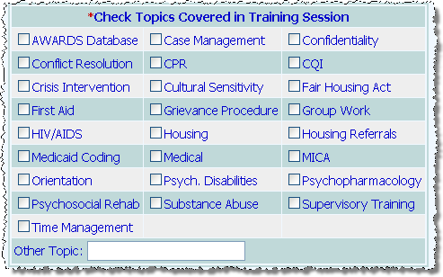 | Use this custom list:  [enter list here]
(training.w: cfg-train-topics)

Option 9 – Staff Training > Training Cost Field
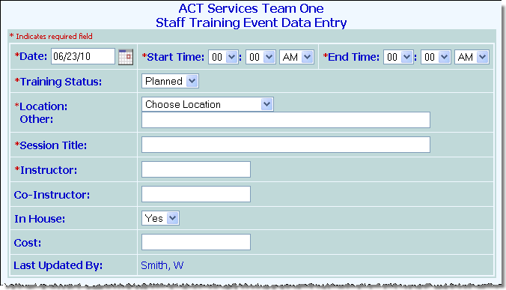
AWARDS Location: Various > Staff Training
Enhancement Description: Adds a Cost field to staff training records, allowing for the capture of training costs. (A value entered into this field is informational only and is not used in any calculations elsewhere in AWARDS.)

Request Details
Setting
Do NOT turn on the Cost field
ADD the Cost field to all Staff Training records
(training.w: cfg-cost-field)

Option 10 – Staff Training > Mandated Training Attendance Option
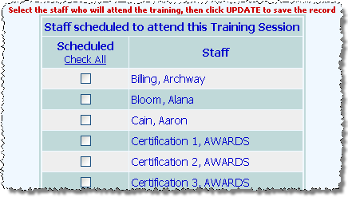
AWARDS Location: Various > Staff Training
Enhancement Description: By default when scheduling attendees for staff trainings, a Scheduled checkbox is displayed to the left of each staff member’s name, as shown in the top image at right. Checking the checkbox corresponding to a staff member indicates that he/she is scheduled to attend that event. A Check All link is also available for easy selection of all staff.
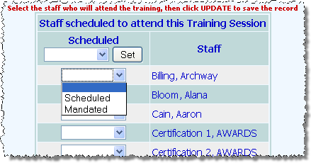
With this enhancement – shown in the second image - the Scheduled checkboxes are replaced with both “Scheduled” and “Mandated” selections to distinguish whether each attendee is scheduled to attend the training, or required to attend, respectively. In addition, the Check All link is replaced with the same selection list and a Set button that can be used to apply a single selection to every staff member, overriding any individual selections previously made. Please note that when this enhancement is requested the Scheduled selection on any existing staff training records is automatically switched over to the new equivalent selection in the drop-down.

Request Details
Setting
KEEP the default scheduled checkboxes
REPLACE the checkboxes with the scheduled/mandated selection list
(training.w: cfg-show-mandated)

