Discharge
AWARDS Implementation Requests Form

Overview
As part of the AWARDS implementation process, agencies/continuums can make adjustments to the information collected during a client’s discharge, to the discharge workflow itself, and to which other Discharge module features are available to users. This document is intended to guide you through each of the available Discharge options, and to provide you a form with which to request them.

Request Form Instructions
To request that the AWARDS discharge functionality be customized for your agency/continuum, do the following:
- Discuss the available options with your AWARDS implementation team and/or any other relevant staff.
- Complete this request form, including the Requestor Information and the Request Details for each option.
- Save the completed form to your PC.
- Email the completed form to your Implementation Consultant or to requests@footholdtechnology.com.
Once your request form has been received, we will review it carefully and the requested options will be deployed to your AWARDS database. We may contact you prior to deployment if, after reviewing your requests, we have any questions or concerns about your selections.

Available Discharge Options
To jump ahead to the information regarding a specific option, click it in the list below.
Discharge Menu
Option 1 – Follow Up Notes Feature
Option 2 – Referrals Out Feature
Discharge Process
Option 3 – Discharge Into Agency Housing Option
Option 4 – Post Discharge Events
Discharge Form / Information
Option 5 – Header Label
Option 6 – Reason for Discharge List
Option 7 – Outcome / Classification List
Option 8 – Anonymous Summary Text Box
Option 9 – Discharge Note Settings
Option 10 – Additional Fields / Options
Option 11 – Referral Options
Option 12 – Destination List
Option 13 – Diagnoses / Medications Display
Discharge Form / Information (cont’d)
Option 14 – Undo Discharge Option
Option 15 – Signature Lines Display

Requestor Information
Customer Name: [enter customer / database name here]
Requestor Name: [enter your name here]

Option 1 – Discharge Menu > Follow Up Notes Feature
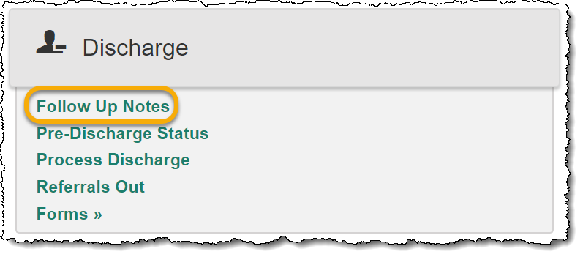
AWARDS Location: Census > Discharge
Enhancement Description: The Follow Up Notes feature is an optional database enhancement (turned off by default) that provides a secondary point of access to the Services – Individual module’s Progress Notes feature, but one which limits data entry to notes for discharged clients only, with note types such as “Post Discharge Follow-Up.”

Request Details
Setting | Programs
Do NOT turn on Follow Up Notes for any program. | All agency programs
ADD Follow Up Notes to the Discharge menu for: | [enter program list here]
(outtake.w: cfg-funotes-btn)

Option 2 – Discharge Menu > Referrals Out Feature
AWARDS Location: Census > Discharge
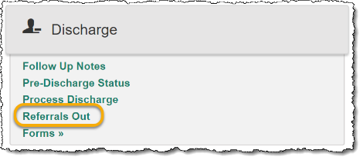
Enhancement Description: The Referrals Out feature is an optional database enhancement (turned off by default) that provides a secondary point of access to the Services – Individual module’s Service Referrals feature. Using Referrals Out/Service Referrals, case managers and counselors can quickly and easily record and report out on outgoing referrals. When turned on, several aspects of this feature are configurable.
- Tip: For a less robust way of recording outgoing referrals for clients at the time of discharge, see Option 11 – Referral Options.

Request Details > Feature Availability
Setting | Programs
Do NOT turn on Referrals Out for any program. | All agency programs
ADD Referrals Out to the Discharge menu for: | [enter program list here]
(outtake.w: cfg-refout-btn)

Request Details > Feature Configuration
If you have chosen to make this feature available to one or more programs (above or at any time in the past), please specify how it should be configured by completing the following. Keep in mind that these configurations impact ALL programs using this functionality at either of its points of access (Services – Individual > Service Referrals – AND – Discharge > Referrals Out).
- Disposition Selection List
Default List | Customized List
Use the default list:  Referred  Accepted  Denied | Use this custom list:  [enter custom list here]
(referout.w: cfg-disposition-list)
- “Disposition” Label
Default Label | Custom Label
Use the default Disposition label | Use this custom label: [enter label here]
(referout.w: cfg-disposition-label)
- Purpose / Need Selection List
Default List | Default List – PLUS – Additions (defaults cannot be removed)
Use the default list:  Benefits/Entitlements  Case Management  Clothing  Education  Employment  Employment Training  Food  Housing  Identification  Legal  Medical  Mental Health Services  Other  Shelter  Transportation | Use the default list WITH these additions:  [enter additions here]
(referout.w: cfg-show-customlist)
- “Purpose / Need” Label
Default Label | Custom Label
Use the default Purpose / Need label | Use this custom label: [enter label here]
(referout.w: cfg-purpose-label)

Option 3 – Discharge Process > Discharge Into Agency Program Option
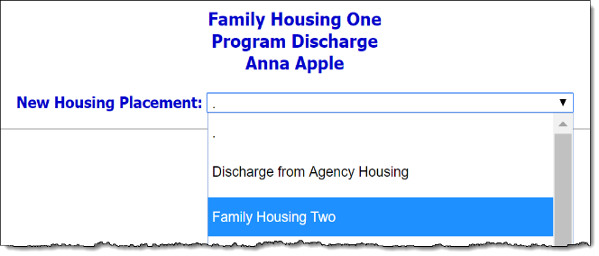
AWARDS Location: Census > Discharge > Progress Discharge
Enhancement Description: By default, when a client is being discharged from a residential program, a New Housing Placement option is provided on the client selection page. This option, which is available to users with the “Admission Referrals Data Entry” permission, enables the client to be discharged directly into another agency residential program that the user has program chart access to, or to discharge that client from agency housing entirely.
If needed, the New Housing Placement option can be turned off so that users are instead forced to discharge all clients from agency housing. If the client is then admitted into another residential program at the agency, that program would be responsible for completing the admission process.

Request Details (not applicable to non-residential programs)
Setting
We do NOT want the New Housing Placement option; remove it.
Continue to display the New Housing Placement option for all residential programs, as is the default.
(discharg.w: cfg-hide-new-housing)

Option 4 – Discharge Process > Post Discharge Chart Events
AWARDS Location: Census > Discharge > Progress Discharge / Services – Individual > Charting Timetable
Enhancement Description: When a client’s discharge is processed, any charting events that are NOT marked as “done” (under Services – Individual > Charting Timetable) are automatically removed from that client’s schedule, with the exception of Post Discharge Follow-Up and Discharge Summary events. This enhancement overrides the default, allowing programs to preserve other charting events so that they remain on the discharged client’s schedule and are accessible via the roster archives. (Note that in multi-step intake programs this enhancement also applies to pending clients with a “withdrawn” or “rejected” status.)
Please keep in mind that programs that elect to retain certain charting events after a client’s discharge will have reminder messages generated for those events. Specifically, messages will be sent seven, fourteen, and twenty-one days prior to the event’s due date if the event is not set to “done.” If the event is still not “done” when the due date is reached, messages will continue every three days (excluding weekends), up to 120 days after the due date.

Request Details
Setting | Events Retained | Program Types
Do NOT retain any events other than the defaults. | Post Discharge Follow-Up  Discharge Summary | All
Retain the defaults AND these additional events: | [enter event list here] * | [enter program types list here]
 | [enter event list here] * | [enter program types list here]
 | [enter event list here] * | [enter program types list here]
 | [enter event list here] * | [enter program types list here]
* Event names must match the labels in AWARDS exactly. (charting.w: cfg-post-discharge-events)

Option 5 – Discharge Form / Information > Header Label
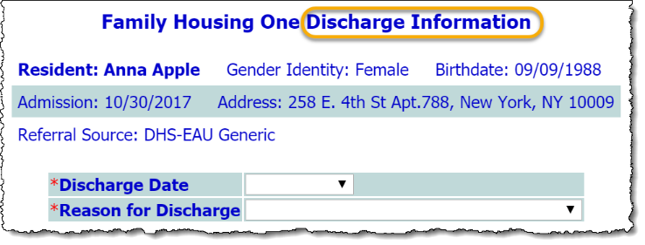
AWARDS Location: Census > Discharge > Progress Discharge
Enhancement Description: By default, the form completed during the discharge process is labeled as “Discharge Information.” This heading is customizable by program type.

Request Details
Setting | Label | Program Types
Use the default label | Discharge Information | All
Use a custom label(s) | [enter label here] | [enter program type list here]
 | [enter label here] | [enter program type list here]
 | [enter label here] | [enter program type list here]
 | [enter label here] | [enter program type list here]
 | [enter label here] | [enter program type list here]
(discharg.w: cfg-discharge header)

Option 6 – Discharge Form / Information > Reason for Discharge List
AWARDS Location: Census > Discharge > Progress Discharge
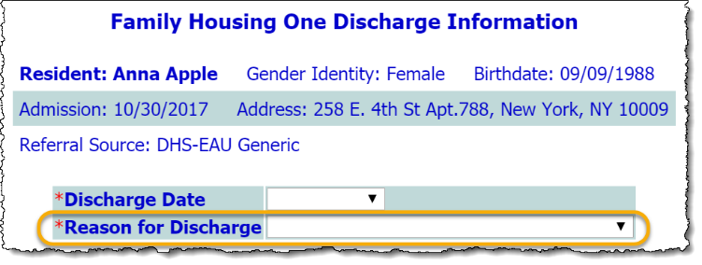
Enhancement Description: The options that populate the Reason for Discharge selection list on the discharge form are configurable. Specifically, the default list can be replaced with a custom list, or preset lists of OMH- or OASAS-mandated selections. Configurations are applied by program type.

Request Details
Setting | List | Program Types
Use the default list | No longer needs current level of care  Dropped out  Functional and/or mental status issues  Substance use issues  Serious behavior issues  Physical or medical issues  Financial issues  Hospitalized  Deceased  Other | [enter program type list here]
Use the OASAS list | OASAS-mandated selections | [enter program type list here]
Use the OMH list | OMH-mandated selections | [enter program type list here]
Use a custom list | [enter list contents here] | [enter program type list here]
 | [enter list contents here] | [enter program type list here]
 | [enter list contents here] | [enter program type list here]
 | [enter list contents here] | [enter program type list here]
 | [enter list contents here] | [enter program type list here]
(discharg.w: cfg-leavereason-list / discharg.w: cfg-customreason-list)

Option 7 – Discharge Form / Information > Outcome / Classification List
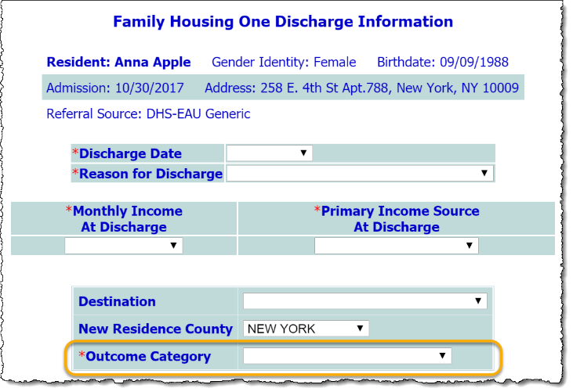
AWARDS Location: Census > Discharge > Progress Discharge
Enhancement Description: By default, the discharge form includes an Outcome Category selection list (for residential program) or a Classification selection list (for non-residential programs). These lists can be used along with the Reason for Discharge option to further describe the type of discharge being processed. For example, you can use a program-specific Reason for Discharge list to report out on individual program discharges, while keeping a more general agency-wide Outcome Category / Classification list to report out on discharges as a whole across your agency.
If tracking two distinct values in this way is not necessary, Outcome Category / Classification can be turned off entirely. If it is kept in place, the selection list contents are configurable. (Note that while the option itself can be turned on/off for individual programs, the selection lists for those options are set by program type.)

Request Details
Setting | List | Programs / Program Types
Turn this option OFF entirely | N/A | [enter programs or program types list here]
Use the default list | Voluntary  Non-voluntary | [enter program types list here]
Use a custom list | [enter list contents here] | [enter program types list here]
 | [enter list contents here] | [enter program types list here]
 | [enter list contents here] | [enter program types list here]
 | [enter list contents here] | [enter program types list here]
 | [enter list contents here] | [enter program types list here]
(discharg.w: cfg-classlist / discharg.w: cfg-outcome-category // discharg.w: cfg-outcomecode / discharg.w: cfg-outcomecode-list)

Option 8 – Discharge Form / Information > Anonymous Summary Text Box
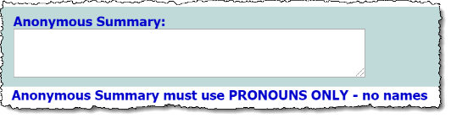
AWARDS Location: Census > Discharge > Progress Discharge
Enhancement Description: Adds an Anonymous Summary text box to the discharge form for one or more programs of your choosing. Once added, you also can choose to make an entry in this text box required, if appropriate.

Request Details
Setting | Programs
Turn this option ON | [enter programs list here]
Make this option required in all programs set to display it | N/A
(discharg.w: cfg-anon-summary // discharg.w: cfg-no-anonsum-required)

Option 9 – Discharge Form / Information > Discharge Note Settings
AWARDS Location: Census > Discharge > Progress Discharge
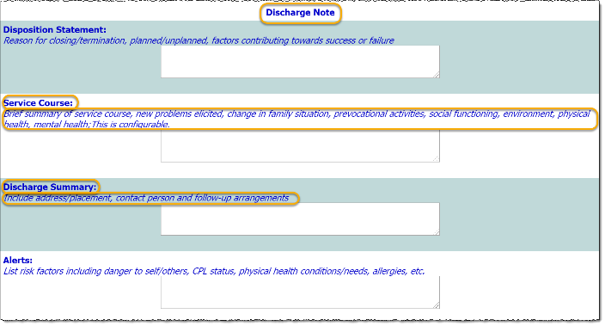
Enhancement Description: By default, the discharge form includes a “Discharge Note” section, comprised of a series of text boxes with instructions. The overall label of that section is configurable, as are some text box labels and instructions. In addition, the entire “Discharge Note” section (including all text boxes it contains) can be set as required for data entry during the discharge process, if appropriate.

Request Details
All components of this enhancement can be set individually at the program level.
- “Discharge Note” Section Heading
Setting | Label | Programs
Use the default label | Discharge Note
Use a custom label(s) | [enter custom label here] | [enter program list here]
 | [enter custom label here] | [enter program list here]
 | [enter custom label here] | [enter program list here]
 | [enter custom label here] | [enter program list here]
 | [enter custom label here] | [enter program list here]
(discharg.w: cfg-discharge-note-header)
- “Service Course” Text Box Label
Setting | Label | Programs
Use the default label | Service Course
Use a custom label(s) | [enter custom label here] | [enter program list here]
 | [enter custom label here] | [enter program list here]
 | [enter custom label here] | [enter program list here]
 | [enter custom label here] | [enter program list here]
 | [enter custom label here] | [enter program list here]
(discharg.w: cfg-servicecourse-heading)
- “Service Course” Instruction Text
Setting | Text | Programs
Use the default text | Brief summary of service course, new problems elicited, change in family situation, prevocational activities, social functioning, environment, physical health, mental health
Use custom text | [enter custom text here] | [enter program list here]
 | [enter custom text here] | [enter program list here]
 | [enter custom text here] | [enter program list here]
 | [enter custom text here] | [enter program list here]
 | [enter custom text here] | [enter program list here]
(discharg.w: cfg-servicecourse-directions)
- “Discharge Summary” Text Box Label
Setting | Label | Programs
Use the default label | Discharge Summary
Use custom label(s) | [enter custom label here] | [enter program list here]
 | [enter custom label here] | [enter program list here]
 | [enter custom label here] | [enter program list here]
 | [enter custom label here] | [enter program list here]
 | [enter custom label here] | [enter program list here]
(discharg.w: cfg-dischargesummary-heading)
- “Discharge Summary” Instruction Text
Setting | Text | Programs
Use the default text | Include address/placement, contact person and follow-up arrangements
Use custom text | [enter custom text here] | [enter program list here]
 | [enter custom text here] | [enter program list here]
 | [enter custom text here] | [enter program list here]
 | [enter custom text here] | [enter program list here]
 | [enter custom text here] | [enter program list here]
(discharg.w: cfg-dischargesummary-directions)
- “Discharge Note” Requirement
Setting | Program List
Discharge Note should NOT be required. | All agency programs
Discharge Note SHOULD be required for: | [enter program list here]
(discharg.w: cfg-require-summary-fields)

Option 10 – Discharge Form / Information > Additional Fields / Options
AWARDS Location: Census > Discharge > Progress Discharge
Enhancement Description: The discharge form can be set to include a variety of fields and options. Many of these fields/options are set to display by default but can be turned off if preferred. Others are only available upon request. By adjusting which fields/options are available on the form you can better control the types of information being recorded there.

Request Details
All components of this enhancement can be set individually at either the program or program type level, as specified.
- “Discharged To” Data Entry > Text Box or Fields
Setting | Description | Program Types
Use the default text box | Displays Discharged To as a single text box in which to enter the “discharged to” address.
Use split fields | Replaces the single Discharged To text box with four distinct fields: Address, City, State, and Zip | [enter program types list here]
(discharg.w: cfg-dischgto-addrs)
- “Alerts” Text Box Display > On / Off
Setting | Programs
Display the Alerts text box for all agency programs, as it is by default.
We do NOT want the Alerts text box for all programs. Turn it OFF for: | [enter programs list here]
(discharg.w: cfg-discharge-alerts)
- “Post Discharge Contact Information” Text Box Display > On / Off
Setting | Programs
Keep the Post Discharge Contact Information text box turned OFF for all agency programs, as it is by default.
Turn ON the Post Discharge Contact Information text box for: | [enter programs list here]
(discharg.w: cfg-postdischarge-contact)
- Various Fields/Options Display > On / Off
All fields/options listed here are turned OFF by default. Check the box for any that should instead be turned ON, and specify the program(s) for which they should be made available.
Setting / Description | Programs
Discharge Time (HH:MM AM/PM)  Displays a field in which to record the time of discharge. | [enter programs list here]
City/Town of New Residence  Displays a drop-down list of customizable counties. | [enter programs list here]
Township of New Residence  Displays a field in which to record township detail. | [enter programs list here]
Employed at Time of Discharge  Displays a Yes/No selection option. | [enter programs list here]
Enrolled in School at Discharge  Displays a Yes/No selection option. | [enter programs list here]
Highest Level of School Completed at Discharge  Displays a selection list with the education options available on the face sheet. | [enter programs list here]
(discharg.w: cfg-discharge-fields)

Option 11 – Discharge Form / Information > Referral Options
AWARDS Location: Census > Discharge > Progress Discharge
Enhancement Description: A simpler alternative to the Referrals Out feature detailed in Option 2. Adds Primary Referral and Secondary Referral drop-down selection lists to the discharge form for specified program types. In addition, changes to the default selection items for these drop-downs can be customized at the agency level.
Note that Primary Referral can be displayed on its own, or in conjunction with Secondary Referral.

Request Details > Feature Availability
Setting | Program Types
Do NOT display these drop-downs on the discharge form. | N/A
Turn ON the Primary Referral drop-down for: | [enter program types list here]
Turn ON Primary Referral AND Secondary Referral for: | [enter program types list here]
(discharg.w: cfg-extra-fields)

Request Details > Feature Configuration
If you have chosen to make available one or both Referral drop-down options (above or at any time in the past), please specify which list of selections to use. While the display of the drop-downs themselves is set at the program type level, this list is configured at the agency level.
Default List | Custom List
Use the default list:  No Referral Made  Inpatient: Acute Psych Unit  Inpatient: State Psychiatric  Residential Treatment Facility  Residential Program  Clinic  Continuing Day Treatment  Day Treatment  Partial Hospitalization  Intensive Psych Rehabilitation Treatment  Psychosocial Club  Private Practitioner: Mental Health  Chemical Dependency Treatment: Inpatient  Chemical Dependency Treatment: Outpatient  Court/Correctional System  Vocational Services  Educational Program  Medical Practitioner  Self Help Group  Non Traditional Treatment Provider  Other  Unknown | Use the following custom list:  [enter custom list here]
(referout.w: cfg-referral-list)

Option 12 – Discharge Form / Information > Destination List
AWARDS Location: Census > Discharge > Progress Discharge
Enhancement Description: When discharging from a residential program, a set of default Destination selections are automatically made available in that selection list; however, this list is configurable.

Request Details (not applicable for non-residential or HMIS programs)
Setting | List | Program Types
Use the default list | 01 OMH State Psychiatric Center  02 Non State Psychiatric Hospital  03 Non OMH Medical Hospital  04 OMH State Congregate CR  05 State RCCA  06 State C&Y CR  07 Voluntary Congregate CR  08 Voluntary Apartment CR  09 Voluntary CR SRO  10 Voluntary RCCA  11 Voluntary C&Y CR  12 Supported Housing  15 Proprietary CR  16 Family Care  17 Independent Living/Own residence  19 With Family/Significant Other  20 Adult Home  21 Municipal Shelter  22 Voluntary Shelter  23 DSS Emergency Shelter | [enter program types list here]
Use a custom list | [enter list contents here] | [enter program types list here]
 | [enter list contents here] | [enter program types list here]
 | [enter list contents here] | [enter program types list here]
 | [enter list contents here] | [enter program types list here]
 | [enter list contents here] | [enter program types list here]
(discharg.w: cfg-resicode / discharg.w: cfg-resicode-list)

Option 13 – Discharge Form / Information > Diagnoses / Medications Display
AWARDS Location: Census > Discharge > Progress Discharge
Enhancement Description: The discharge form can be set to include a variety of read-only diagnoses- and medications-related information, pulled from the clients face sheet and corresponding Medical module records. Many of these sections of information are set to display by default but can be turned off if preferred.

Request Details
All components of this enhancement can be set individually at the program type level, as specified.
- Current Diagnoses Display > On / Off
Setting | Program Types
Display the Current Diagnoses section of read-only data for all agency programs, as it is by default.
Current Diagnoses should NOT be shown for all programs. Turn it OFF for: | [enter program types list here]
(discharg.w: cfg-fdiags)
- Current and Expired Medications Display > On / Off
Setting | Program Types
Display both current AND expired Medications in read-only format for all agency programs, as is the default.
Display only current Medications in read-only format for: | [enter program types list here]
Medications should NOT be shown for all programs. Turn it OFF for: | [enter program types list here]
(discharg.w: cfg-discharge-meds)
- Pharmacy Information Display > On / Off
Setting | Program Types
Display Pharmacy Information in read-only format for all agency programs, as is the default.
Pharmacy Information should NOT be on for all programs. Turn it OFF for: | [enter program types list here]
(discharg.w: cfg-discharge-pharmacy)
- Contra-Indicated Meds Display > On / Off
Setting | Program Types
Display Contra-Indicated Meds in read-only format for all agency programs, as is the default.
Contra-Indicated Meds should NOT be on for all programs. Turn it OFF for: | [enter program types list here]
(discharg.w: cfg-discharge-contra-meds)

Option 14 – Discharge Form / Information > Undo Discharge Option
AWARDS Location: Census > Discharge > Progress Discharge
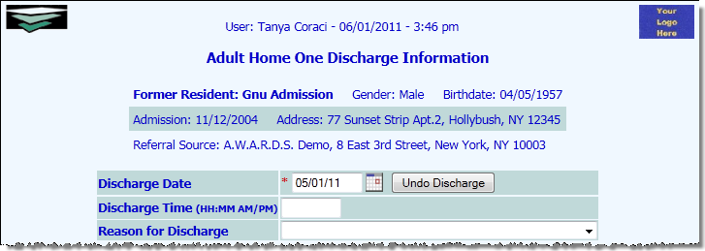
Enhancement Description: When requested adds an Undo Discharge button to completed discharge records for the purposes of reversing that discharge if necessary. This feature is only applicable to non-residential program discharges, or for residential programs when the client has been discharged from agency housing. If the client has a subsequent admission into a residential program, or if the apartment/bed which the client was discharged from is no longer available, the discharge cannot be undone using this option and instead must be addressed using the Program History Corrections tool by a user with the proper authority.
When a discharge is undone using the Undo Discharge feature, all information previously collected on the discharge form is removed, and the client is placed back on the program roster as if they never left.
IMPORTANT! Keep in mind that once this feature is turned on for a program, ANY USER with access to process a discharge in that program can also undo a discharge there. There is no permission to limit which users can access this feature, other than the permission to process a discharge. If only select staff should have the ability to undo a discharge, we recommend use of the Program History Corrections tool instead.

Request Details
Setting | Programs
Do NOT display Undo Discharge for any program. | N/A
Turn ON the Undo Discharge option for: | [enter programs list here]
(discharg.w: cfg-xdischarge)

Option 15 – Discharge Form / Information > Signature Lines Display
AWARDS Location: Census > Discharge > Progress Discharge
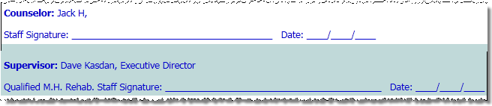
Enhancement Description: When the discharge form is viewed in read-only format, whether by entering a discharge record in report mode, or by viewing the confirmation page for a discharge that was just processed or updated, signature lines are set to display at the bottom of the page. These signature lines are configurable in a variety of ways.

Request Details (not applicable when electronic signatures are in use)
All components of this enhancement can be set individually at the agency, program, or program type level, as specified.
- Supervisor Signature Line > Label
Setting
Use the default label on the supervisor signature line (Qualified MH Rehab Staff) for all agency programs.
Use this custom label on the supervisor signature line for all agency programs: [enter custom label here]
(discharg.w: cfg-discharge-supersig)
- Supervisor Name Display > On/Off
Setting | Programs
Display the supervisor’s name in read-only format with the signature line for all agency programs, as is the default.
Do NOT display the supervisor’s name in all programs. Turn it OFF for: | [enter programs list here]
(discharg.w: cfg-show-supervisor-name)
- Service Coordinator Signature Line > Label
Setting | Label | Programs
Use the default label for service coordinator signature lines. | Staff Signature | All agency programs
Use a custom label for service coordinator signature lines. | [enter custom label here] | [enter programs list here]
 | [enter custom label here] | [enter programs list here]
 | [enter custom label here] | [enter programs list here]
 | [enter custom label here] | [enter programs list here]
 | [enter custom label here] | [enter programs list here]
(discharg.w: cfg-discharge-staffsig)
- Service Coordinator Name Display > On/Off
Setting | Programs
Display the service coordinator’s name in with the signature line for all agency programs, as is the default.
Turn the service coordinator’s name OFF in the signature line display for: | [enter programs list here]
(discharg.w: cfg-show-caseworker-name)
- Client Signature Line Displayt > On/Off
Setting | Programs
Do NOT display a signature line for the client for all agency programs, as is the default.
Turn ON a client signature line in the following programs: | [enter programs list here]
(discharg.w: cfg-dischg-client-sign)
- Custom Signature Block Option > On / Off
Setting | Signature Line Labels * | Program Types
Use the default service coordinator and supervisor signatures.
Replace the defaults with custom signature lines. | [enter signature lines here] | [enter program types list here]
 | [enter signature lines here] | [enter program types list here]
 | [enter signature lines here] | [enter program types list here]
 | [enter signature lines here] | [enter program types list here]
 | [enter signature lines here] | [enter program types list here]
* Separate multiple signature lines labels with commas (discharg.w: cfg-signature-items)

