Service Contacts
Implementation Request form
As part of the implementation process of AWARDS, agencies are able to configure what service contacts look like within the Services module. Possible configuration options are described in this document, which also serves as a request form.
In order to for service contacts in your agency/continuum to be configured according to these options, please do the following:
- Please discuss the possibilities with your AWARDS implementation team and/or with any other relevant staff to determine whether or not they will be appropriate for deployment in your AWARDS database. Because some enhancements can be deployed for specific programs or program types (rather than for the database as a whole), it is important to review each enhancement carefully to see how it is deployed and to determine who you would like it turned on for.
- Complete this implementation request form and save it to your PC. Be sure to complete the “Requestor Information” section, and to provide all of the asked for information for those enhancements you would like to have turned on.
- Email the completed request form to requests@footholdtechnology.com by replying to the original email as soon as possible. Be sure to send the actual Word document file as an attachment in the email – do NOT copy and paste the content of the document into an email.
Once your request form has been received, we will review it carefully and the requested options will be deployed. A client services representative may contact you prior to deployment if, after reviewing your requests, he/she has any concerns about your selections, or if he/she thinks there are enhancements you have not chosen which could be of benefit to you.

requestor information
Agency/continuum name: [enter the name of your agency or continuum here]
Requestor name: [enter your name]

Table of Contents
Option |  | Page

progress notes, contacts log, and group notes Options
Option 1 – Display Additional Contact Details |  | Page 4
Option 2 – List of Locations |  | Page 5
Option 3 – Minute Increments Within Services |  | Page 6
Option 4 – Service Language |  | Page 7

Progress Notes and contacts log options
Option 5 – Service Type Filter |  | Page 8
Option 6 – Display Service Contact End Times in Reports |  | Page 9
Option 7 – Display Medicaid Number |  | Page 10
Option 8 – Service Types |  | Page 11

Progress Notes Options
Option 9 – Progress Note Time Written Stamp |  | Page 12
Option 10 – Minimum Note Duration |  | Page 13
Option 11 – Successful/Unsuccessful |  | Page 14
Option 12 – Motivational Interviewing Link |  | Page 15
Option 13 – Extra Note Types |  | Page 16
Option 14 – Link Collateral Notes to Service Plans |  | Page 17
Option 15 – Periodic Summary Note - Allow Note to Be F2F |  | Page 18
Option 16 – Periodic Summary Note - Hide N/A Fields on Note |  | Page 19
Option 17 – Periodic Summary Note - Display Grid w/Attendance Calendar and Service Contacts Table |  | Page 20
Option 18 – Expand List of Notes on Index |  | Page 22
Option 19 – Expand List of Notes on Data Entry Page |  | Page 23
Option 20 – Option to Include Program Appointment Notes |  | Page 24
Option 21 – Omit Employment Related Notes When Running A Progress Notes Report |  | Page 25
Option 22 – Progress Notes Nightly Keyword Alert Scan |  | Page 26
Option 23 – Prevent Future Start Times |  | Page 26
Option 24 – Extra Drop-Down Field |  | Page 27
Option 25 – Progress Note Writer Stamp |  | Page 28
Option 26 – Default Duration Value (for Progress Notes and Daily Checklists) |  | Page 29

contacts log options
Option 27 – Direct and Indirect Time |  | Page 30

supportive services checklist options
Option 28 – Extra Fields |  | Page 31
Option 29 – Supportive Services Funding Sources |  | Page 32
Option 30 – Apply Services to Household Members |  | Page 33
Option 31 – Re-Label Primary Problem |  | Page 32
Option 32 – Prevent Future Start Times |  | Page 33

group notes options
Option 33 – Co-Leader Option for Group Activities |  | Page 36
Option 34 – Allow Multi-Program Attendance for Groups |  | Page 38
Option 35 – Prevent Future Start Times |  | Page 39
Option 36 - Telehealth |  | Page 40
PROGRESS NOTES, GROUP NOTES, SUPPORT SERVICES CHECKLIST, DAILY CHECKLIST
Option 37 – Auto-Calculate Duration or End Time |  | Page 41
Option 38 – Printable Client Identifiers |  | Page 42
ADDITIONAL SERVICE CONTACTS OPTIONS
Option 39 – Charting Event Permissions |  | Page 43

progress notes, contacts log, and group notes Options

Option 1 - display additional contact details
Enhancement location: Services - Individual > Contacts Log > select client > Create new or edit contact
Services - Group > Group Notes > select group > Create new or edit group note
Services – Individual > Progress Notes > select client > Create new or edit progress note

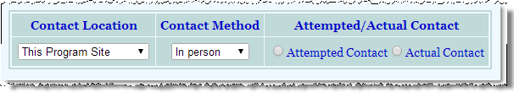
Enhancement description: With this enhancement, all of the additional fields listed below will display in the all of the following locations. This group of fields is turned on for all programs by default; however they can be turned off as a set.

Contacts Log
- Contact Location – Drop-down list containing a configurable list of locations (see Option 3 to configure the location list).
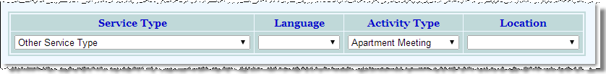
- Contact Method – Hard coded drop-down list containing these options: In Person, Phone Call, Postal Mail, Email, Fax, Other.

Group Notes
- Location - Drop-down list containing a configurable list of locations (see Option 3 to configure the location list).

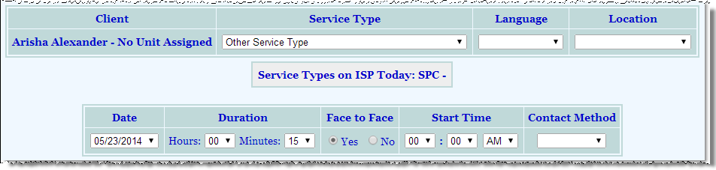
Progress Notes
- Location - Drop-down list containing a configurable list of locations (see Option 3 to configure the location list).

- Contact Method – Hard coded drop-down list containing these options: In Person, Phone Call, Postal Mail, Email, Fax, Other. This is a hard-coded list that cannot be configured.
 | Do not display these fields for any program type.
 | Please turn these fields on in all locations for the following program types: | [enter program type list here]
this enhancement is deployed at the program type level.
Please select one of the following:
(services settings: cfg-contactinfo-plus)

Option 2 – list of locations
Enhancement location: Services - Individual > Contacts Log > select client > Create new or edit contact
Services -Group > Group Notes > select group > Create new or edit group note
Services - Individual > Progress Notes > select client > Create new or edit progress note
Enhancement description: With this option, programs can create a custom drop-down list for the Location field in used in contacts log, group notes and progress notes.

this option is deployed at the program level.
To request changes to the default list, enter the complete list you would like display in the column to the right. Each list item should appear on its own line, as opposed to being separated by commas.
Default List | Instead of the default list, use this complete list for the program types listed:
This Program Site  Consumer Residence  Consumer Workplace  Other Program Site  Other Service Provider  Hospital  Jail Other Site | For these programs:  [enter program list here] | Use this list:  [enter list here]
 | For these programs:  [enter program list here] | Use this list:  [enter list here]
 | For these programs:  [enter program list here] | Use this list:  [enter list here]
 | For these programs:  [enter program list here] | Use this list:  [enter list here]
(contactlog.w: cfg-location-list)

Option 3 – Minute increments within services
Enhancement location: Services - Individual > Contacts Log > select client > Create new or edit contact
Services – Group > Group Notes > select group > Create new or edit group note
Services - Individual > Progress Notes > select client > Create new or edit progress note
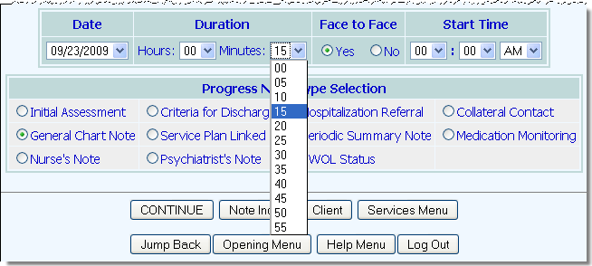
Enhancement description: By default, when writing a progress note, group note or contact log, the minute drop-down selection lists for the Duration and Start Time of the contact is broken up in five minute intervals.
Likewise, when entering group activity attendance, the minute drop-down in the From and To fields contains multiple of five minutes.
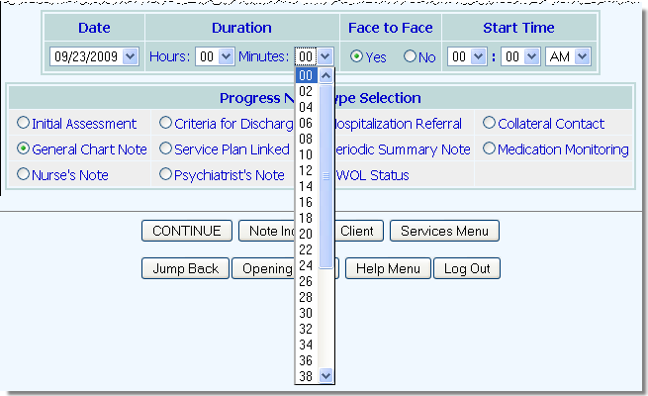
This enhancement allows an agency to set these minute selection lists to use a new time increment.
For example, it can be set to have the minute increments be broken into one minute, two minutes, or even 15 minute intervals. Any increment from one through 59 is permissible.
Here, the minute increment has been set to two:
Any changes to the minute increments will be reflected in both the Duration and Start Time minute selection lists.

This enhancement is deployed at the program type level.
Please select one of the following:
 | No, we would not like this enhancement. Use the default 5 minutes.
 | Yes, we would like this enhancement. Please turn it on for the following program types and minute durations: | For these Program Types:  [enter program type list here] | Use this Increment Interval:  [enter increment interval here]
 |  | [enter program type list here] | [enter increment interval here]
 |  | [enter program type list here] | [enter increment interval here]
 |  | [enter program type list here] | [enter increment interval here]
(servmenu.w: cfg-minute-increments)

Option 4 – service language
Enhancement location: Services -Individual > Contacts Log > select client > Create new or edit contact
Services -Group > Group Notes > select group > Create new or edit group note
Services -Individual > Progress Notes > select client > Create new or edit progress note
Enhancement description: This enhancement allows agencies to record the language in which a service was provided. Specifically, a Language drop-down list will be added to the settings page when creating or updating a progress note, group note or contacts log.
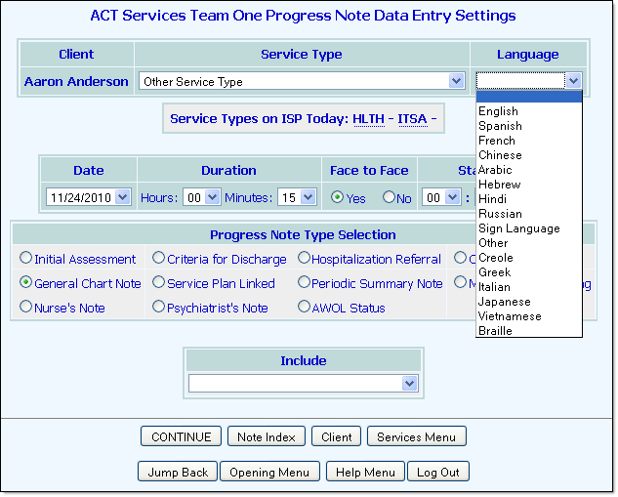
The data entered on the service will also appear on the corresponding report (the progress notes report, group notes report and contacts log report).
The drop-down list contents of the Language field will match the options that appear in the list for Primary Language on the program’s face sheet.
This information will not be available in any DataBridge tables.

this option is deployed at the Program Type level.
Please select from the following:
No, we would not like this enhancement.
Yes, we would like this enhancement. Please turn it on for contacts log & contacts log report for the following program types:
[enter program type list here]
Yes, we would like this enhancement. Please turn it on for group notes & group note report for the following program types:
[enter program type list here]
Yes, we would like this enhancement. Please turn it on for progress notes & progress notes report for the following program types:
[enter program type list here]
(services: cfg-service-language)

Progress Notes and contacts log options

Option 5 - service type filter in reports
Enhancement location: Reports Menu
Services -Individual > Utilization Reports > Contacts Log
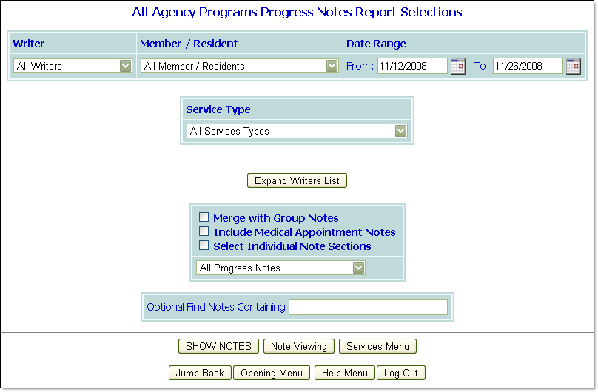
Enhancement description: This enhancement adds a Service Type selection to the contacts log and/or progress note report settings pages for the purposes of filtering report content by service type.
The Service Type selection, shown here on the Progress Note Report Selections page, contains all of the selected program’s service types, as well as an “All Service Types” selection to which the drop-down defaults. When a service type is selected from this list and the report is run, its content is limited to only those contacts log records or progress notes for the selected type.
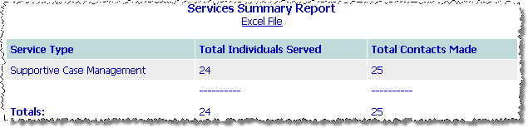
Additionally, when this enhancement is deployed a Services Summary Table of service type data is added to the bottom of each report it is turned on for, an example of which is shown here from the contacts log report.
The table includes:
- Service Type – The selected service type(s) for which the report was run.
- Total Individuals Served – An unduplicated count of the number of members who have contacts (when running the contacts log report) or progress notes (when running the progress notes report) of that service type. If a client has multiple contacts/notes of the same service type, AWARDS adds only one to this count.
- Total Contacts Made / Total Notes Written – Displays the number of contacts of that service type in total (when running the contacts log report) or progress notes of that service type in total (when running the progress notes report). If a client has multiple contacts/notes of the same service type, AWARDS will add each one to this count.
The summary table also includes an Excel File link for the purposes of exporting the information to Microsoft Excel.
This enhancement is deployed at the agency level.
No, we would not like this enhancement.
Yes, we would like this enhancement. Please make it available for the:
Contacts Log Report
Progress Notes Report
Please select from the following:
(CUSTOMIZATION: cfg-ctlog-svcfilter)
(CUSTOMIZATION: cfg-pnotes-svcfilter)

Option 6 - display service contact end times in reports
Enhancement location: Reports Menu

Enhancement description: This enhancement adds an end time to a progress note when viewing the Progress Notes Report in the Reports module. It can also be applied to the Contacts Log Report.
By default, these reports display the note start time and duration. This enhancement will update the time displayed to show the start and end time with a hyphen in between (i.e., 1:00 PM – 2:00 PM). The duration will also be displayed, as it is today.
The end time displayed is calculated by AWARDS using the start time and duration. It is not a separate data entry field.

this enhancement is deployed at the Program level.
Please select all that apply:
No, we would not like this enhancement.
Yes, we would like this enhancement. Please turn on the Progress Note end time for the listed programs:
[enter program list here]
Yes, we would like this enhancement. Please turn on the Contacts Log end time for the listed programs:
[enter program list here]
(pnrptdo.w: cfg-extra-fields)
(ctlogrpt.w: cfg-extra-fields)

Option 7– display medicaid number
Enhancement location: Services –Individual > Progress Notes > select client > Create new or edit progress note
Services -Individual > Contacts Log > select client > Create new or edit contact

Enhancement description: This enhancement displays the client’s Medicaid ID in report mode into the header of certain service items. Locations in which this field can be displayed are:
- Progress Note data entry page (on the header of the page, preceding the Note Type detail)
- Progress Notes Report (preceding the Face-to-face field)
- Contacts Log data entry page (on the header of the page, after the Consumer Name)
- Contacts Log Report (preceding the Minutes field)
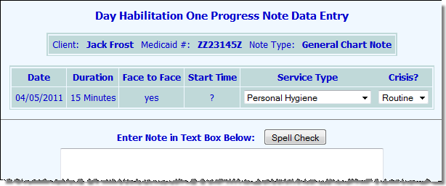
The Medicaid ID displayed is entered in the client’s record using the Entitlements module Certified Entitlements feature.
In this screen shot, the Medicaid ID appears in the header of a progress note data entry page.

this enhancement is deployed at the Program level.
 | No, we would not like this option.
 | Yes, we would like this enhancement for the options checked off below. | Please turn on this enhancement for the programs listed below:
 | Progress Note data entry page | [enter program list here]
 | Progress Notes Report | [enter program list here]
 | Contacts Log data entry page | [enter program list here]
 | Contacts Log Report | [enter program list here]
Please select from the following:
(ispset.w: cfg-medicaidnum-display)

Option 8 - SERVICE TYPES
Enhancement location: Services -Individual > Progress Notes > select client > Create new or edit existing
Services -Individual > Contacts Log > select client > Create new or edit existing

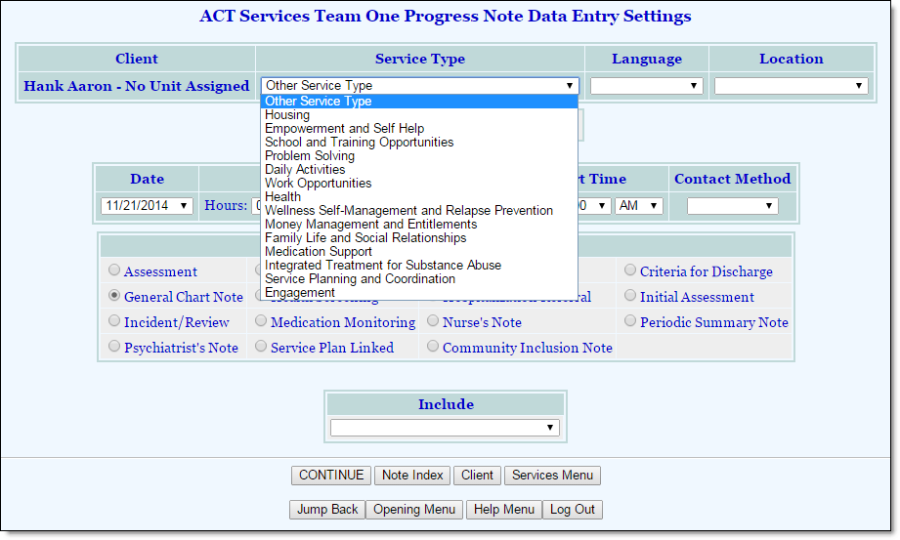
Enhancement description: This enhancement allows you to configure the Service Type Selection options when writing a new progress note or contacts log entry for a client.
You may add new service types to the existing list, or replace existing options with a new list.
If you choose to remove an existing service type, the type will only show for existing progress notes and contacts log entries with that type in report mode, and will not be available on the Service Type selection list in data entry mode.
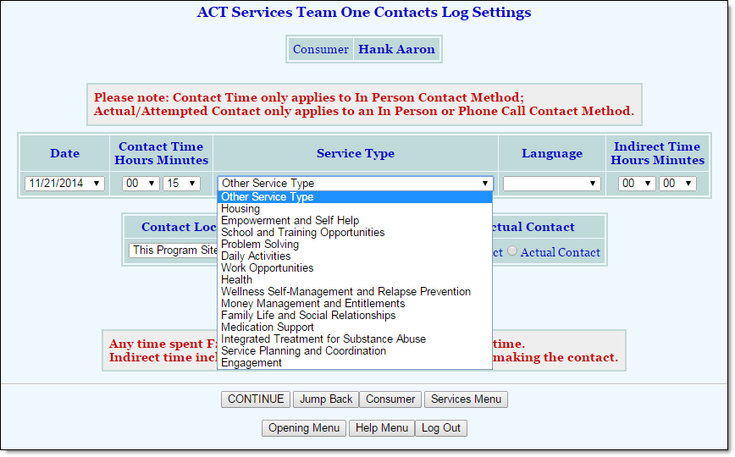

this enhancement is deployed at the Program Type level.
New Implementations - Please refer to the Service Type Spreadsheet, which will be provided by your Implementation Consultant. Contact your Implementation Consultant if you have any questions regarding your service types.
Existing AWARDS Agencies – Please contact the Help Desk or your Senior Project Manager if you’d like to make changes to your service types.
(SERVICE-TYPES: cfg-master-codes)
(SERVICE-TYPES: cfg-master-list)
(SERVICE-TYPES: cfg-custom-codes)
(SERVICE-TYPES: cfg-custom-list)

progress notes options

Option 9 - progress notes time Written stamp
Enhancement location: Reports Menu

Enhancement description: With this enhancement, the time a progress note is written will be recorded in the database. Similar to how the Date Written field gets updated any time the progress note is edited, the time written will also update when an edit is made. However, if your agency has chosen to have the Date Written field always reflect the date the note was originally entered, the time written will behave the same way.
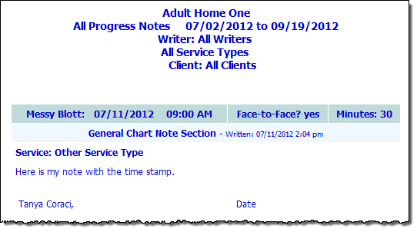
The time will be recorded going forward only and will not be available for existing notes. This field will be visible when the note is viewed in read-only on the editing index, Progress Notes Report, Progress Notes ReportBuilder and Service Contacts ReportBuilder.

this enhancement is deployed at the Program and agency level.
Please select all that apply:
No, we would not like this enhancement.
Yes, please display the Time Written field for progress notes written in the following programs:
[enter program names here]
Please have the Date Written (and Time Written) field remain static and always reflect the original date (and time) of data entry. (Agency-wide)
(pnrptdo.w:cfg-extra-fields)
(pnotdone.w:cfg-notedate)

Option 10 - minimum Note duration
Enhancement location: Services –Individual > Progress Notes > select client > Create new or edit progress note

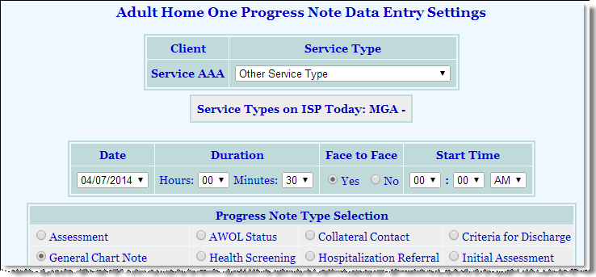
Enhancement description: The minimum number of minutes in the Duration field for a progress note can be configured. The minimum duration set will automatically display when creating a new note.
If a number of minutes less than the minimum duration is entered, an error message appears stating such along with the minimum number of minutes required.

Note that the Duration field can be set to be auto-calculated as well. See Option 34 in this document for details on that option.

this option is deployed at the program level.
Please select one of the following:
 | No, we would not like this enhancement.
 | Yes, we would like this enhancement. Please turn it on for the following programs and minimum duration: | For these programs:  [enter program list here] | Use this minimum time: [enter minimum duration here]
 |  | [enter program list here] | [enter minimum duration here]
 |  | [enter program list here] | [enter minimum duration here]
 |  | [enter program list here] | [enter minimum duration here]
(pnotmake.w: cfg-minimum-time)

Option 11 – Successful/unsuccessful
Enhancement location: Services –Individual > Progress Notes > select client > Create new or edit progress note
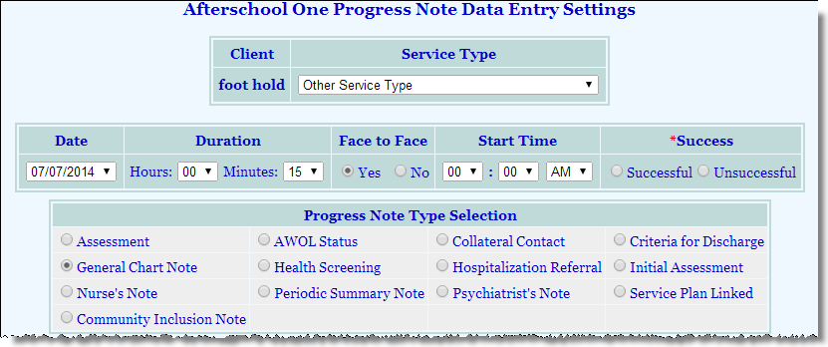
Enhancement description: With this option, a new Success field can be added to the Progress Notes Data Entry Settings page, with radio buttons for “Successful” and “Unsuccessful.” When this field is turned on, it displays as a required field.

this enhancement is deployed at the program type level.
Please select one of the following:
 | Do not display these fields for any program type.
 | Please turn these fields on in all locations for the following program types: | [enter program type list here]
(pnotmake.w: cfg-fields)

Option 12 – Motivational interviewing link
Enhancement location: Services -Individual > Progress Notes > Create new or edit progress note

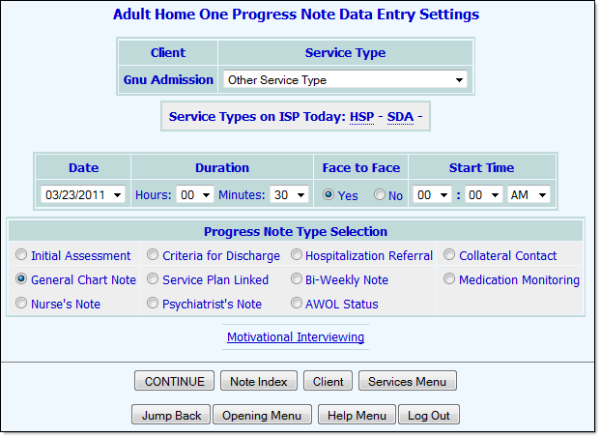
Enhancement description: With this enhancement, a Motivational Interviewing hyperlink will display on the Progress Note Data Entry Settings page.
When users click on the link, a new window will open containing tips on motivational interviewing. To see the form in detail, click here.
When this option is turned on for progress notes, it appears on the settings page, beneath the Progress Note Type Selection table.
While this link can be turned on for any program types, it was intended for ACT programs.

this enhancement is deployed at the Program Type level.
Please select one of the following:
No, we would not like this enhancement.
Yes, we would like this enhancement. Please turn it on for the following program types:
[enter program type list here]
(pnotmake.w: cfg-MI-hyperlink)

Option 13 - extra note types
Enhancement location: Services –Individual > Progress Notes > select client > Create new or edit progress note

Enhancement description: This enhancement allows you to configure the Progress Note Type Selection options when writing a new progress note for a client.
This enhancement allows agencies to create new note types for program types. Agencies can incorporate the new types into the existing options, or completely replace the existing options with a new list.
The custom note types will be available when creating a new progress note, when running a progress notes report, or a contacts log report.
If you choose to remove an existing note type, the type will only show for existing progress notes with that type in report mode, and will not be available for selection in data entry mode.

this enhancement is deployed at the Program Type level.
New Implementations - Please refer to the Note Type Spreadsheet, which will be provided by your Implementation Consultant. Contact your Implementation Consultant if you have any questions regarding your note types.
Existing AWARDS Agencies – Please contact the Help Desk or your Senior Project Manager if you’d like to make changes to your note types.

(pnotmake.w: cfg-extra-notetype-labels)
(pnotmake.w: cfg-extra-notetype-codes)
(pnotmake.w: cfg-xnotetype-labels)
(pnotmake.w: cfg-xnotetype-codes)

Option 14 – Link collateral notes to service plan
Enhancement location: Services –Individual > Progress Notes > select client > Create new or edit progress note
Enhancement description: When entering a Progress Note, this option can be turned on to link services on the Service Plan to a Collateral Note. If turned on, and the note type selected is Collateral Contact and the Service Type selected matches an active service type on the client’s plan, users will be able to select corresponding plan objectives on the Progress Notes Data Entry page.

This enhancement is deployed at the Program type level.
No, we would not like this enhancement.
Yes, we would like this enhancement. Please turn it on for the following program types:
[enter program type list here]
(pnotmake.w: cfg-collateral-isp)

Option 15 - periodic summary note - allow note to be f2f
Enhancement location: Services –Individual > Progress Notes > Create new or edit periodic summary note

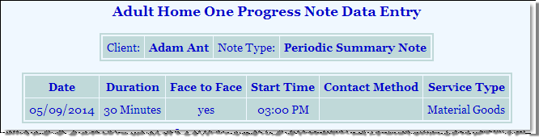
Enhancement description: By default, periodic summary notes are not set to record Duration, Start Time, or Face-to-Face information, even if data selections are made by the user. With this enhancement, these fields will save on the periodic summary note as entered by the user.

This enhancement is deployed at the program type level.
Please select one of the following:
No, we would not like this enhancement.
Yes, we would like this enhancement for the following program types:
[enter Program Types list here]
(pnotmake.w: cfg-f2f-periodic)

Option 16 – periodic summary note - hide n/a fields on note
Enhancement location: Services –Individual > Progress Notes> Create new or edit periodic summary note

Enhancement description: By default, periodic summary notes are not set to record Duration, Start Time, or Face-to-Face information, even if data selections are made by the user. When the previous option (14) to save Duration, Face-to-Face and Start Time for the periodic summary note is not turned on and this data is not saved, these fields can be hidden on the periodic summary note.
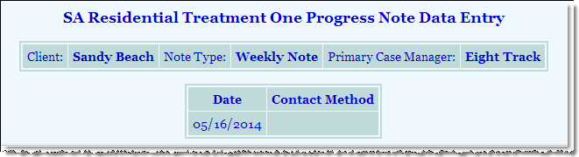
Duration, Face-to-Face and Start Time have not been set to save for this program, and have been hidden in data entry and report mode.

Data Entry Mode
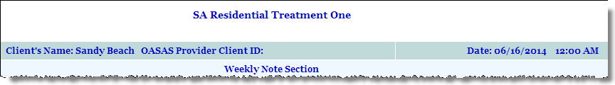
Report Mode

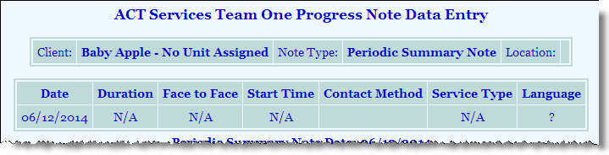
Duration, Face-to-Face and Start Time have not been set to save for this program, and display in data entry and report mode.

Data Entry Mode
Report Mode

This enhancement is deployed at the program type level.
Please select one of the following:
No, we would not like this enhancement.
Yes, we would like this enhancement for the following program types:
[enter Program Types list here]
(pnotmake.w: cfg-hide-NA-fields)

Option 17 – Periodic Summary note - display grid with RECEPTION DESK attendance calendar AND SERVICE ContactS table
Enhancement location: Services -Individual > Progress Notes > select client > Create new or edit periodic summary note

Enhancement description: With this enhancement, a grid containing attendance documentation entered using the Reception Desk module will display in data entry and report mode for any Periodic Summary Note. Writers will be able to specify a date range. Group, Group Activity Type and Individual Contact Log data can also display for the same period. When Group and Individual Contact Log data is set to display, and documentation exists, but clock times for the same time periods/duration have not been entered in Reception Desk, a black flag will mark that date on the grid.
This option is primarily applicable if you are using the Reception Desk module in AWARDS. However, if you do not use the Reception Desk module, but want display Group/Individual Contact documentation information from over a period of time within a Periodic Summary Note, this option may be useful for you. Note, however, that the Attendance Grid and black flags will still appear.
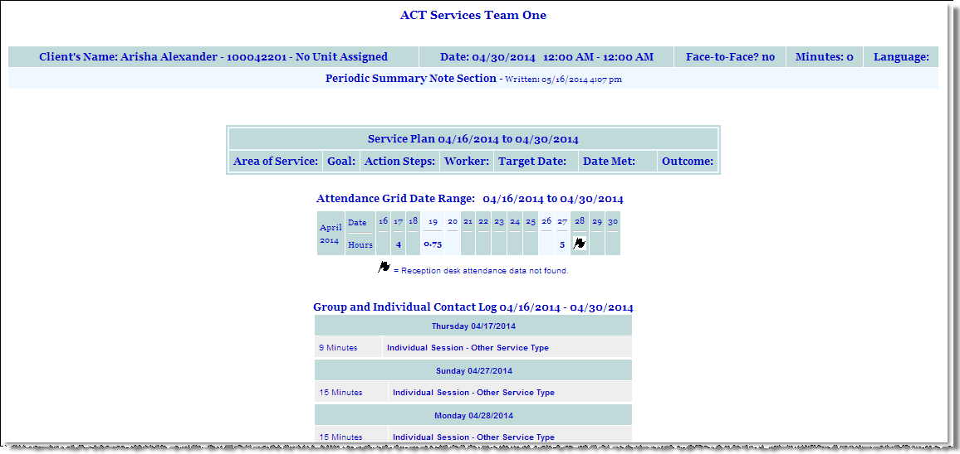

This enhancement is deployed at the Program type level.

Step 1: Please enter the Program Types you would like each option to display:
Option | Display for the following programs: | Do NOT display for any program types:
Display Grid ONLY – Grid will show attendance documented using Reception Desk. Grid will show a black flag where there is Group Notes documentation but no Reception Desk Documentation. | [enter Program Type list here]
Display Service Contacts Table: Group Documentation > Group Names Only – Table will show attendance documented using Group Notes (Contact Date, Group Name, Start Time, End Time) | [enter Program Type list here]
Display Service Contacts Table: Group Documentation > Include Group Activity Types – Table will display Group Activity Type in addition to Contact Date, Group Name, Start Time, and End Time. | [enter Program Type list here]
Display Service Contacts Table: Individual Progress Notes/Contacts Log Documentation – Table will display client Contacts documented using the Progress Notes or Contacts Log modules. Contacts Log entries will display Contact Date and Duration. Progress Note entries will display Contact Date, Duration and Start Time (if entered). | [enter Program Type list here]
(services settings: cfg-contactgrid)
(services settings: cfg-grpatnd-tbl)
(pnotmake.w: cfg-contactgrid-grouptype)
(services settings: cfg-contactlog-grid)

Option 18 - expand list of notes shown on Index
Enhancement location: Services -Individual > Progress Notes > select client
Enhancement description: With this enhancement, the Progress Note Index can be set to display all notes written for the selected consumer in the past X number of days, not just the notes written by the logged in user. If set, notes by other writers display in the index as links but they will not be editable.
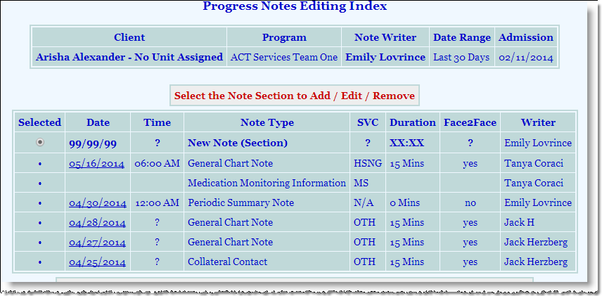

this option is deployed at the program level.
Please select one of the following:
 | No, we would not like this enhancement.
 | Yes, we would like this enhancement. Please turn it on for the following programs and number of days: | For these programs:  [enter program list here] | Use this number of days:  [enter number of days here]
 |  | [enter program list here] | [enter number of days here]
 |  | [enter program list here] | [enter number of days here]
 |  | [enter program list here] | [enter number of days here]
(pnotndx.w: cfg-expand-list)

Option 19- expand list of notes shown on Data Entry page
Enhancement location: Services -Individual > Progress Notes > select client > Create new note
Enhancement description: With this enhancement, the Progress Note Data Entry page can be set to display all notes written for the selected consumer in the past X number of days, not just the notes written by the user entering the note. If set, notes by other writers display in a read-only at the bottom of the data entry page and will not be editable.

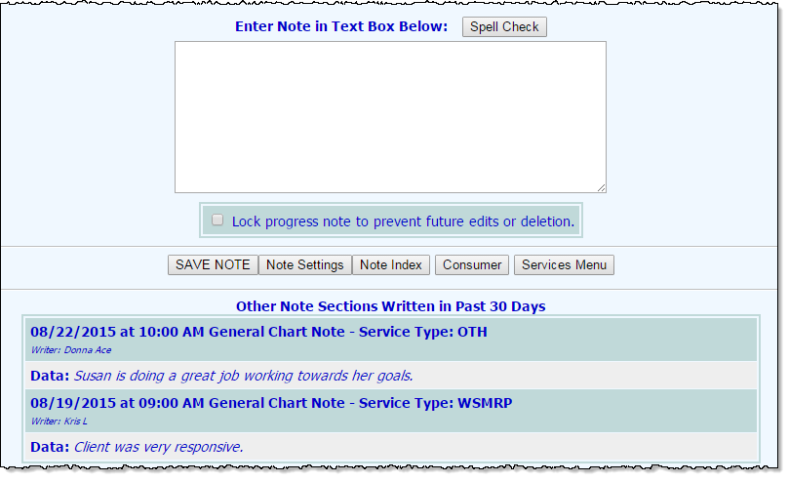

this option is deployed at the program level.
Please select one of the following:
 | No, we would not like this enhancement.
 | Yes, we would like this enhancement. Please turn it on for the following programs and number of days: | For these programs:  [enter program list here] | Use this number of days:  [enter number of days here]
 |  | [enter program list here] | [enter number of days here]
 |  | [enter program list here] | [enter number of days here]
 |  | [enter program list here] | [enter number of days here]
(pnotmake.w: cfg-allnotes-display)

Option 20 - option to include program appointment notes on Progress Notes Report
Enhancement location: Reports Menu

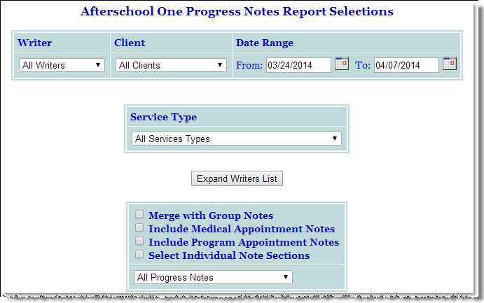
Enhancement description: This option provides the ability to include Program Appointment Notes in the Progress Notes Report. A new Include Program Appointment Notes check box will be added to the Progress Notes Report Selections page. Program Appointment notes are added via the Calendar as a Program Appointment for a single client.
This option is only applicable if you are using the Calendar module in AWARDS.

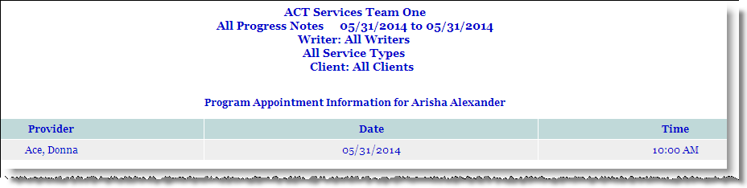
When this option is selected, Program Appointment details (Provider, Date and Time) will display in the Progress Notes Report when an appointment falls within the specified date range.

this option is deployed at the program level.
Please select one of the following:
No, we would not like this option.
Yes, we would like this option. Please turn this on for the following programs:
[enter program list here]
(pnrptset.w: cfg-programappoints)

Option 21 - Omit Employment related notes when running a progress notes report
Enhancement location: Reports Menu

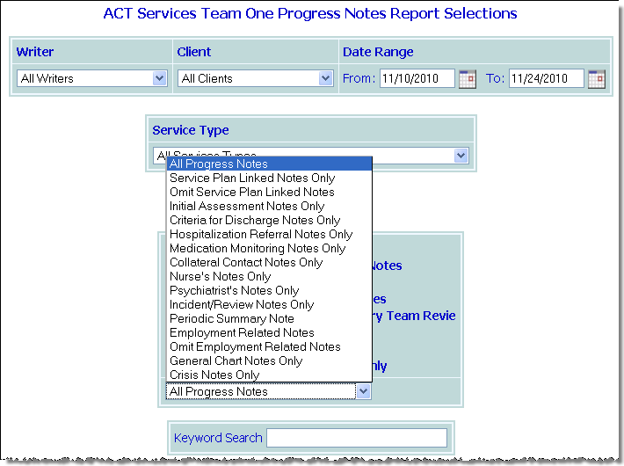
Enhancement description: With this enhancement, an “Omit Employment Related Notes” option will display on the drop-down list on the Progress Notes Report Selections page when running a progress note report within the Services module. If this option is selected, employment notes written from within the Employment module will not be included in the report.
This option applies only if the Employment Module is in use.

this enhancement is deployed at the Program Type level.
Please select one of the following:
No, we would not like this enhancement.
Yes, we would like this enhancement. Please turn it on for the following program types:
[enter program type list here]
(pnrptset.w: cfg-employment-notes)

Option 22 – PROGRESS NOTE NIGHTLY KEYWORD ALERT SCAN
Enhancement location: Messages> Internal Audit Messages
Enhancement description: With this enhancement, the list of alert keywords which generate Progress Notes Nightly Keyword Scan internal audit messages can be configured.
The default list of alert words is listed below:

- 911
- alcohol
- amphetamine
- angeldust
- angel-dust
- barbiturate
- cannabis
- cocain
- crack
- danger
- drink
- drug
- fight
- halllucinogen
- harm
- heroin
- hurt
- inhalant
- kill
- lsd
- marihuana
- marijuana
- methadone
- pcp
- popper
- pot
- pot,
- rape
- suicid

The default list will recognize partial words (suicid for suicide, suicidal). If a custom list is used, only the exact word will be recognized in the nightly keyword scan.

this enhancement is deployed at the agency level.
No, we would not like this enhancement. Continue using the default list.
Yes, please replace the default list with the list below for the agency.
[enter keyword alert list here]
(busrules.w:cfg-keyword-list)

Option 23– PREVENT FUTURE START TIMES
Enhancement location: Services -Individual > Progress Notes > select client > Create new or edit a note
Enhancement description: With this enhancement, note writers will not be able to save a progress note with a future Start Time that has not yet passed. For example, a note with a Start Time of 2:00 pm could not be saved at noon that day. (Future dates are not allowed by default.)

this enhancement is deployed at the Program level.
No, we would not like this enhancement. Allow future Start Times.
Yes, prevent future Start Times from being saved in the following programs:
[enter program list here]
(cfg-prevent-future-prognote-starts)

Option 24– EXTRA Drop Down Field
Enhancement location: Services -Individual > Progress Notes > select client > Create new or edit a note
Enhancement description: With this enhancement, a new drop-down field can be added to the Progress Note Data Entry Settings page, and the label and drop-down selection can be customized to capture any information needed.
For agencies using BillingBuilder, this field option allows for Ratio based billing when set up during the billing setup process.

this enhancement is deployed at the Program TYPE level.
No, we would not like this enhancement.
Yes, turn on this extra field.
If turned on, please designate labels and list contents for this field:
For these program types:  [enter program types list here] | Use this label:  [enter label here] | And these drop-down selections:
[enter program types list here] | [enter label here] | [enter list options here]
[enter program types list here] | [enter label here] | [enter list options here]
[enter program types list here] | [enter label here] | [enter list options here]

(pnotmake.w, cfg-ratio-label, cfg-ratio-values, pnotmake.w: cfg-fields)

Option 25 – Progress note writer stamp
Enhancement location: Reports Menu > Progress Note and Service Contacts ReportBuilders, Progress Notes Report
Services – Individual > Progress Notes
Enhancement description: With this enhancement, the name of each progress note’s writer will be recorded in AWARDS – both for new notes moving forward, and for existing notes that have not yet been e-signed and/or locked. The note writer’s name will be displayed with a “Written By:” label and displayed when notes are viewed in read-only report mode (from the note index) or from within the Progress Notes Report, or the Progress Notes or Service Contacts ReportBuilders, as shown here:
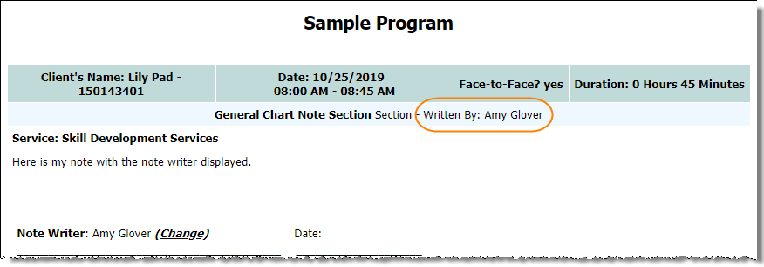

this enhancement is deployed at the Program level.
No, we would not like this enhancement.
Yes, please display Note Writer information for progress notes written in the following programs:
[enter program names here]
(pnrptdo.w:cfg-extra-fields)

Option 26 – default duration value (progress notes and daily checklists)
Enhancement location: Services – Individual > Progress Notes data entry
Services – Individual > Res/Day Hab Daily Checklist data entry
Enhancement description: With this enhancement, the default Duration value that is automatically displayed for progress notes (and/or res/day hab daily checklist records, when in use) can be customized to reflect your preferred value during data entry.
When requesting this enhancement, keep in mind that:
- Default duration is specified in minutes; however, if the default value is greater than 60, it will be converted to display both hours and minutes in AWARDS. For example, if the default duration is 90, the Duration value in AWARDS displays as “1 Hour 30 minutes.”
- The default minutes you choose to use must work with the minute increments available if you have chosen to use Option 3 – Minute Increments within Services, configured earlier in this document.
- If you have chosen to use Option 10 – Minimum Note Duration, configured earlier in this document, the default value is less than that minimum, and the user does not adjust the value during data entry, a error message is received noting the minimum requirement.
- Duration can also be set to be auto-calculated using Option 37 – Auto Calculate Duration or End Time, configured later in this document.
- If using this enhancement for progress notes AND daily checklist records, the default settings cannot be configured individually – the same default value must be used for both.
This enhancement is deployed at the program type level.
Please select one of the following:
No, we would not like this enhancement turned on for any program types.
Yes, we would like this enhancement. Turn it on for:

Progress Notes Only
Progress Notes AND Daily Checklist

Use the following program type and default duration combinations:

Program Type(s) | Duration (in minutes)
[enter program type(s) list] | [enter default duration]

(pnotmake.w: cfg-duration-default)
(cfg-duration-default-in-checklist)

contacts log options

Option 27 – direct and indirect time
Enhancement location: Services -Individual > Contacts Log > select client > Create new or edit contact
Enhancement description: A variety of fields can be set to display during on contact log records and reports. This option will allow you to determine what time fields will display on the forms and reports, allowing users to view and edit information entered in those fields.
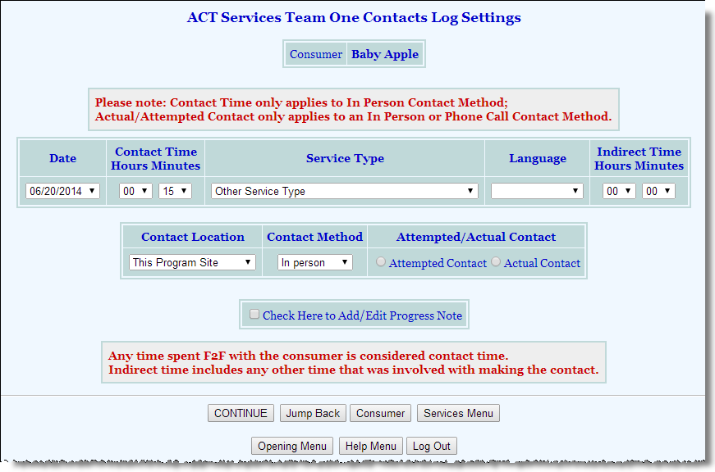
This option will allow programs the ability to track both direct and indirect contact times used when contacting a client. Time is entered in hours and or minutes on the Contacts Log Settings page.
The Contact Time field records direct contact time which is defined as a Face-to-Face contact. In order for AWARDS to record a direct contact, the Contact Method must be “In-Person” and the Attempted/Actual Contact selection must be “Actual Contact.”
The Indirect Time field records any other contact or other time involved in making the contact.

This enhancement is deployed at the agency level.
Please select one of the following:
No, we would not like this enhancement.
Yes, we would like this enhancement. Please turn on both direct and indirect time fields.
(services settings: cfg-indirectmin)

supportive services checklist options

Option 28- extra fields
Enhancement location: Services -Individual > Contacts Log > select client > Create new or edit contact
Enhancement description: With this option, two new fields can be added to the Support Services Checklist. They are:
- Cost - A text field to note the total cost of the units of service being documented.
- End Date - A date field to note the last date on which the service will be provided. When this field is turned on, it displays as a required field.
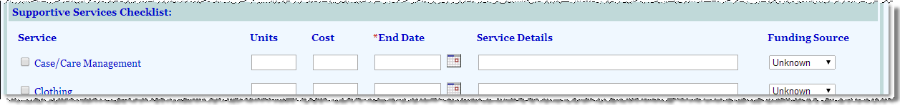

this option is deployed at the program type level.
No, we would not like this option.
Yes, we would like this option. Please turn fields on for the following program types.
Cost – [enter program type list here]
End Date – [enter program type list here]
(svcchecklist.w: cfg-extra-fields)

Option 29 - supportive services funding sources
Enhancement location: Services -Individual > Contacts Log > select client > Create new or edit contact
Enhancement description: This option allows for a custom list of funding sources available for selection for each supportive service provided when the Supportive Services Checklist is set to display.
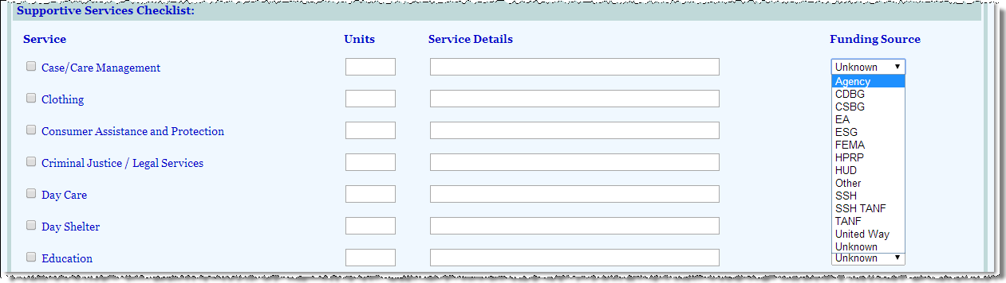

this option is deployed at the agency level.
Please select one of the following:
No, we would not like this option.
Yes, we would like this option. Please use the following list of funding sources:
[enter funding sources list here]
(svcchecklist.w: cfg-supp-svcs-funding-src)

Option 30 - Apply services to household members
Enhancement location: Services -Individual > Contacts Log > select client > Create new or edit contact
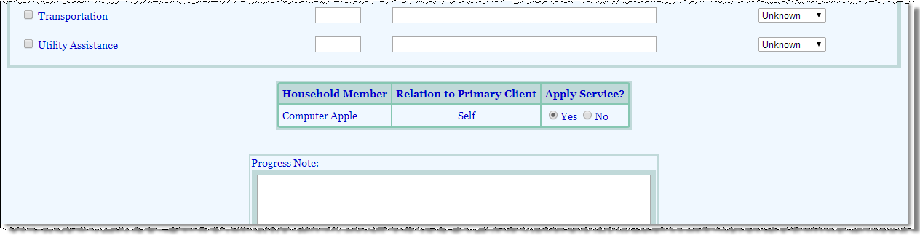
Enhancement description: With this option, for programs set to use the Household functionality and the Support Services Checklist, the Apply Service? radio button selection will default to “Yes” for additional household members enrolled in the program. This option applies only if the Household feature is turned on for your agency’s database.

this option is deployed at the program level.
Please select one of the following:
No, we would not like this option. Leave the default selection as “No”.
Yes, we would like this option. Please set the default to “Yes” for the following programs:
[enter program list here]
(svcchecklist.w: cfg-household-default)

Option 31 – Re-Label primary problem
Enhancement location: Services –Individual > Contacts Log > select client > Supportive Services Checklist
Enhancement description: With this option, the Primary Problem Area label on Supportive Services Checklists can be re-labeled.

this option is deployed at the program type level.
Please select one of the following:
No, we would not like this option. Leave the default label.
Yes, we would like this option. Please set the default to “Yes” for the following programs:
[enter program type list here]
(contactlog.w, cfg-primary-problem-label)

Option 32 – PREVENT FUTURE START TIMES
Enhancement location: Services –Individual > Contacts Log > select client > Supportive Services Checklist
Enhancement description: With this enhancement, note writers will not be able to save a checklist with a future Start Time that has not yet passed. For example, a checklist with a Start Time of 2:00 pm could not be saved at noon that day. (Future dates are not allowed by default.)

this enhancement is deployed at the Program level.
No, we would not like this enhancement. Allow future Start Times.
Yes, prevent future Start Times from being saved in the following programs:
[enter program list here]
(cfg-prevent-future-svcchecklist-starts)

GROUP NOTE options

Option 33 - co-leader option for group activities
Enhancement location: Services -Group > Group Schedule Setup > Group Schedules
Services -Group > Group Notes > Create New Note > Co-Leader Option
Reports Menu
System Setup > Business Rules > Electronic Signature Rules

Enhancement description: With this enhancement, staff members will be able to select a Group Co-Leader when writing creating a group activity schedule or writing a group note (for either a scheduled or unscheduled group).
When creating a group activity schedule, a Group Co-Leader multi-selector field will appear for each line of the schedule, next to the Group Leader field. The names that appear in this list are staff who have chart access to the program. This allows users to assign multiple co-leaders for the group, by pressing CTRL while selecting co-leader names. Once saved, the group will appear on all co-leader calendars, and any group notes written for the group will be pre-populated with these co-leader names.
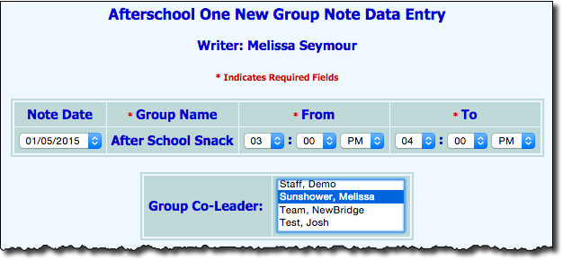
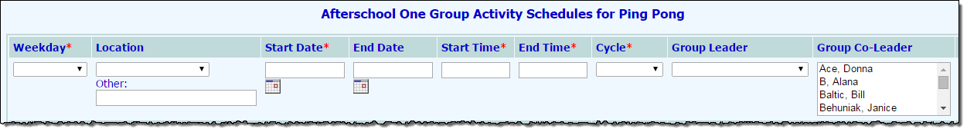
When writing a group note, the Group Co-Leader multi-selector field will be pre-populated with the co-leader names (if any were selected at the time of group scheduling). Edits to the pre-populated list that appears on the group note can be made, if needed. For notes written with co-leaders selected, the co-leader name will display when viewed in report mode.
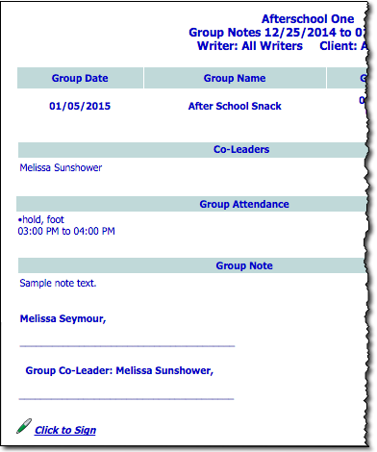
In addition, if the co-leader option is turned on, a signature line for the co-leader is added at the bottom of the group notes in read-only mode, along with a Date line. With this enhancement a corresponding electronic signatures business rule option is also added under System Setup > Business Rules > select program > Electronic Signature Rules > Group Notes that, when checked off, will enable a user to e-sign those notes for which he or she has been selected as the co-leader during the note data entry process. Once a note is e-signed, that signature replaces the default blank signature line.
When viewing the Activities Attendance Report (by entering Activities in report mode) and sorting by “Activity,” the co-leader information will display in its own column. This column will also be added to the Excel spreadsheet version of the report.
The “Co-Leader” and “Co-Leader Count” report options will also appear on the Group Notes ReportBuilder and Service Contacts ReportBuilder.

This enhancement is deployed at the Program type level.
Please select one of the following:
No, we would not like this enhancement.
Yes, we would like this enhancement for the following program types:
[enter Program Types list here]
(cfg-co-leader)

Option 34 – allow multi-program attendance for groups
Enhancement location: Services –Group > Group Notes > Create New Note > select program> Include
Selected Program> select members

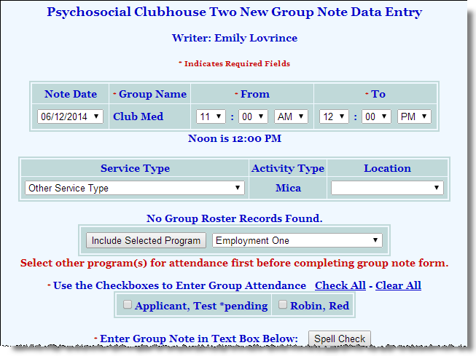
Enhancement description: With this enhancement, clients from other programs can be selected for group attendance when writing a group note. Clients in the primary program will be listed first on the New Group Note Data Entry page, followed by clients in other programs when included.
When writing a group note, a button labeled Include Selected Program will display along with a drop-down containing a list of all agency on the Group Notes Data Entry page below Service Type and Location. To add members from other programs, select the program name and click the Include Selected Program.

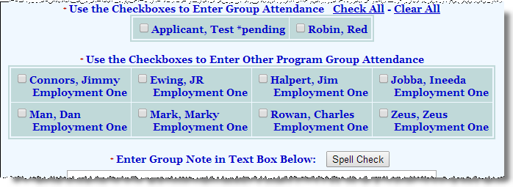
Clients admitted to the primary program will appear first on this page.
Clients from all additional programs selected, will display in alphabetical order with their program name listed below. Multiple programs may be selected for group attendance.

This enhancement is deployed at the Program level.
Please select one of the following:
No, we would not like this enhancement.
Yes, we would like this enhancement for the following programs:
[enter program list here]
(gnotemake.w: cfg-multi-prgm-attendance)

Option 35 – PREVENT FUTURE START TIMES
Enhancement location: Services –Group > Group Notes data entry
Enhancement description: With this enhancement, note writers will not be able to save a group note with a future Start Time that has not yet passed. For example, a group note with a Start Time of 2:00 pm could not be saved at noon that day. (Future dates are not allowed by default.)

this enhancement is deployed at the Program level.
No, we would not like this enhancement. Allow future Start Times.
Yes, prevent future Start Times from being saved in the following programs:
[enter program list here]
(cfg-prevent-future-groupnote-starts)

Option 36 – TELEHEALTH
Enhancement location: Services – Group > Group Notes
Services reports (various)
BillingBuilder
Enhancement description: To accommodate documentation needs when utilizing telehealth in a group setting, the following enhancements are available. Using these enhancements – which are turned on as a set when requested - group notes can be documented to reflect any combination of in person and telehealth attendees as needed.
- Group Notes Data Entry - Telehealth Option for Attendees - Adds a Telehealth checkbox for each attendee specified as present in that group during group notes data entry. To indicate that an individual attended the group via telehealth, simply check off this new option during the group note data entry process. The checkbox is available for both scheduled and unscheduled groups in programs of the type for which the enhancement has been turned on, when the following criteria are met:
- The attendee’s name is checked off during group note data entry
- A scheduled participant’s status is set in the group note to “present” (Individuals who are not scheduled attendees can be checked off as attending via telehealth by clicking Show Full Program Roster to Expand Attendance and checking the appropriate names, at which point the Telehealth option is automatically displayed for those individuals.)
Tip: If the location of the group is set to “Telehealth” the Telehealth checkbox is automatically checked for any of the group’s attendees. If you have a large group where most participated via telehealth, set the location to “Telehealth,” use the Check All option to select everyone, and then make adjustments to the attendees and individual telehealth status details as needed.
- Group Notes Reporting - Telehealth Data Variable - When the group notes telehealth optional enhancement is turned on, an equivalent Telehealth data variable is available in related reports throughout AWARDS. Specifically, in the Group Notes ReportBuilder, Group Notes Report, Service Contacts ReportBuilder, and when merging group notes into the Progress Notes Report.
- BillingBuilder - Telehealth (Group Notes) Procedure Option - When the new Telehealth option is enabled for group notes data entry as detailed above, you can also link it to billing procedures as a requirement for billing those procedures. Specifically, to create this linkage, a new Telehealth (Group Notes) drop-down option is available on the second screen during billing procedures setup. By default, the drop-down selection is blank, meaning a group note for a client will be billable regardless of whether the new Telehealth checkbox is selected.

this enhancement is deployed at the Program type level.
No, we would not like this enhancement.
Yes, make the group notes telehealth functionality available for the following program types:
[enter program type list here]
(gnotmake.w cfg-fields)

progress notes, group notes, support services checklist, daily checklist

Option 37 – Auto-calculate duration or end time
Enhancement location: Progress Notes
Group Notes
Support Services Checklist
Daily Checklist
Enhancement description: When entering a service contact, the Start Time field will always be required, along with either Duration or End Time – depending on how this option is configured. So either Start Time and Duration will be required data entry fields, or Start Time and End Time will be required data entry fields. Whichever of the two fields (Duration or End Time) is NOT required will be populated with a read-only value that is automatically calculated based on the information you provide in the required fields.
For example, Progress Notes could have data entry fields for Start Time and End Time, and have Duration be the calculated field.
By default, End Time is required when entering Group Notes and Duration is auto-calculated. By default, Duration is required when entering Progress Notes and Checklists and End Time is auto-calculated.

This enhancement is deployed at the Program type level.
Leave default settings in place.
Require Duration to be entered for the following program types when entering Group Notes
[enter program type list here]
Require End Time to be entered for the following program types when entering Progress Notes and Checklists.
[enter program type list here]
(pnotmake.w: cfg-duration-or-endtime)
(gnotmake.w: cfg-duration-or-endtime)

Option 38 – Printable client Idenitifiers
Enhancement location: All client specific records
Enhancement description: With this option, agencies can enable identifiers, such as the client’s name, AWARDS ID, Medicaid ID, Chart ID, and any configured Client Identifiers, to print in the header of all client-specific records.
Available options are Medicaid ID, AWARDS ID, and any Unique Identifier types set to display within the Entitlements Client Identifiers feature.

This enhancement is deployed at the Program type level.
 | No, we would not like this enhancement.
 | Yes, we would like this enhancement. Please turn it on for the following program types with specified identifiers: | For these program types:  [enter program types here]  For these program types:  [enter program types here]  For these program types:  [enter program types here] | Use these identifiers:  [enter identifiers here]  Use these identifiers:  [enter identifiers here]  Use these identifiers:  [enter identifiers here]
(cfg-printable-identifiers-list, cfg-printable-identifiers)

additional service contacts options

Option 39 – Charting EVENT PERMISSIONs
Enhancement location: Services –Individual > Charting Events
System Setup > Permissions

thESE enhancementS aRE deployed at the AGENCY level.
Enhancement description: With this enhancement, a new Data Entry/Access permission will be added to the database called “Restrict Charting Event Due Date Data Entry.” Users assigned this permission will not be able to edit the Due Date of charting events, once they are added to a client’s schedule.
With this permission, users can still create new events, but once saved they cannot edit the Due Date.
No, we would not like this permission made available.
Yes, please make this permission available for the agency.
(cfg-datadolist – add “readonly chart due dates”)
(cfg-datadolabel – add “Restrict Charting Event Due Date Data Entry”)
Enhancement description: With this enhancement, a new Data Entry/Access permission will be added to the database called “Restrict Charting Event Deletion.” Users assigned this permission will not be able to delete existing charting events.
With this permission, users can still create new events, but once saved they cannot delete them.
No, we would not like this permission made available.
Yes, please make this permission available for the agency.
(cfg-datadolist – add “restrict charting event deletion”)
(cfg-datadolabel – add “Restrict Charting Event Deletion”)
Enhancement description: With this enhancement, a new Data Entry/Access permission will be added to the database called “Charting Event Done Date Data Entry.” Users assigned this permission will be allowed to add, update, and remove charting event done dates, including done dates for service plans (under Services – Individual > Service Plans).
This also turns on the “Plan Effective Date Data Entry” data entry/access permission, which allows users to enter an Effective Date for plans and reviews using the Services – Individual > Plans and Reviews feature. Adding an Effective Date locks the plan/review from editing.
No, we would not like this permission made available.
Yes, please make this permission available for the agency.
(cfg-datadolist – add “chart dane dates”)
(cfg-datadolabel – add “Chart Events Done Dates Data Entry”)
(charting.w: cfg-done-dates-permission)

